# Kings School Dubai LLC

Address: 3rd 26th St - Dubai (Umm Suqueim3)

School system: British system (UK)

Current rating: Outstanding

Enrollment grade: FS1-Year6

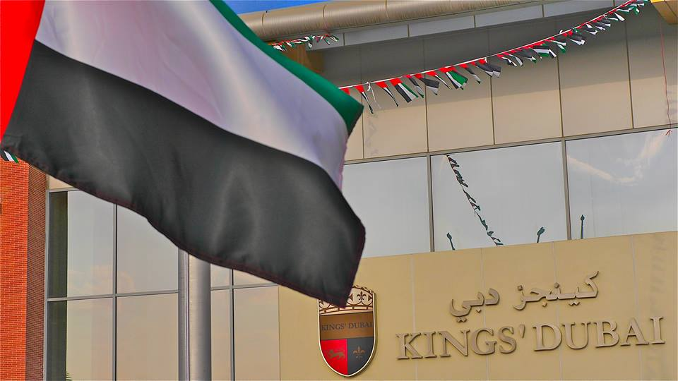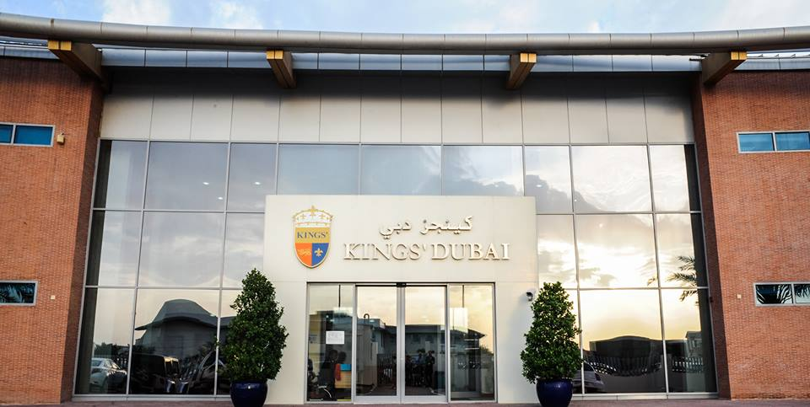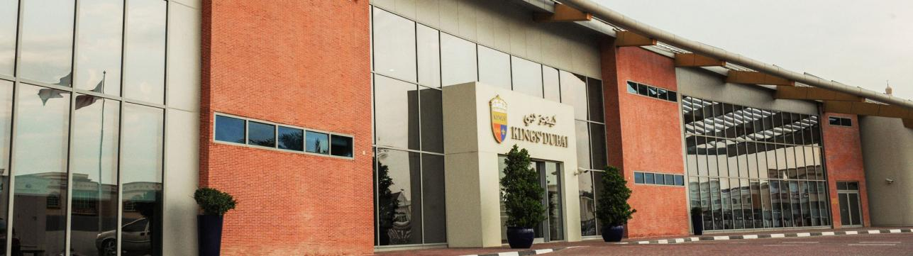

**School Introduction**

Kings School Dubai was founded in 2004 and is adjacent to the Sailing Hotel. It is one of the highest ranked British schools in Dubai's Out Standing. According to data from the Dubai Board of Education, Kings School Dubai has been listed as one of the most successful schools in the UAE since 2008, with the highest rating from the Dubai Board of Education. From 2016 to 2017, we have been granted exemption from inspection by the Dubai Ministry of Education KHDA. In September 2014, two new schools under the brand were established - Nad Al Sheba King School and Al Barsha King School, both of which were rated as good during the first inspection in 2016/17. King Albasha was rated excellent in the third inspection of 2018-19, while Nad Al Sheba School was rated very good, with newer schools allowing King's brand to provide school education from FS1 to secondary school for the first time. The King's School of Albasha is located on Umsukem Road in the southern part of Albasha; Nadal al Sheba King's School is located near Dubai's Silicon Oasis, developed by Meydan and the upcoming Sheikh Mohammad Bin Rashid City. Students between Dubai King's School and Al Assah King's School are provided with paid shuttle buses for parents who have children in both campuses.

Dubai King's College admits students aged 3-11 and provides English education from kindergarten to primary school; Nadal al Sheba King's School admits students aged 2-15; Nadal al Sheba King's School admits students aged 3-18.

Dubai King's Primary School is a very popular primary school that follows the curriculum of the UK and aims to replicate the high standard achievements of England's best preparatory and public schools.

King's School Dubai is the most successful school in the UAE: our school is the only one and has been rated as "outstanding" every year since the UAE government began its school rating. Our academic approach is based on the British education system, but at the same time, we also recognize the importance of integrating excellent international education culture into our school's teaching methods. We provide every child with a caring education and a rich and colorful experience. King's School Dubai has a good reputation and is your true high-quality choice.

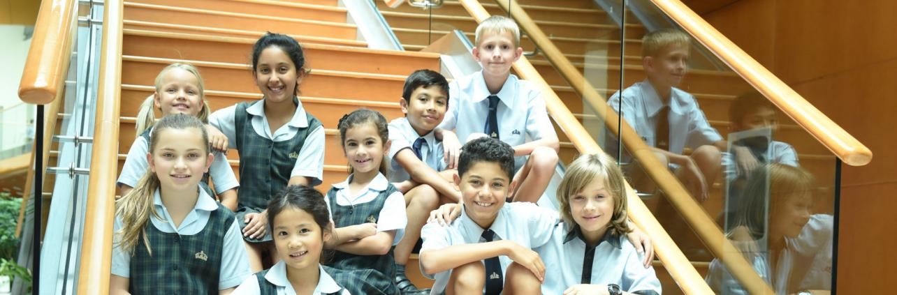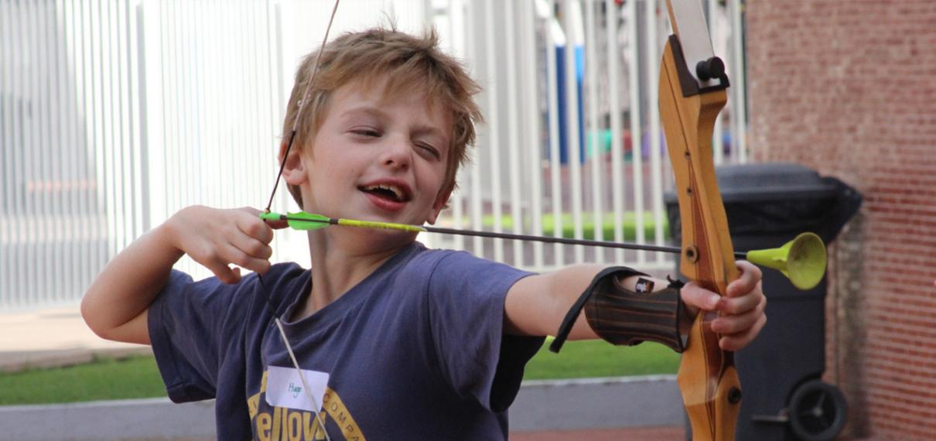

**Principal's message**

Head of School

"I feel very privileged to lead such a wonderful school, along with our dedicated team of learning and teaching professionals, so that we can continue to develop and inspire our young learners who will of course be our leaders of tomorrow."

Bede Higgins

**Educational philosophy**

Kings School Dubai provides the best education and services for children aged 3-11, effectively unleashing their potential through the collective efforts of children, parents, leaders, employees, and teachers.

The curriculum adopts an innovative educational thinking model, allowing children to unleash their infinite value potential in limited space. To further enrich the courses offered, the school has set up programs in Arabic, Spanish, sports, swimming, music, and Islamic culture. Utilize advanced teaching equipment to promote and stimulate children's interest in learning.

Kings School Dubai is also very strict in terms of teaching. There are corresponding evaluations for new students entering the society. FS1 and FS2 will be observational assessments that focus more on whether students have the ability to integrate into the group. Starting from Year 1, there will be written tests that involve listening, speaking, reading, and writing, and students need to have a certain foundation in English. Grades 5-6 even require the provision of prescribed exam scores. If the assessment does not meet the admission requirements, the application will be retained for one year, and the test will be conducted again in the next academic year. The school quota is very tight, and after applying, everyone enters the waiting queue. When the quota is released, they will receive a phone call from the school. When there are too many waiting personnel, the application channel for that stage will be closed.

**High quality teachers**

The teacher-student ratio in primary school is 1:13. According to UAE standards, this is very low, which means that staff should be able to give students good personal attention. The teacher turnover rate has also been consistently low - only 10% in the previous academic year - indicating that this is a happy and stable team. The average level in the United Arab Emirates is between 20% and 22%.

**Advanced Course Settings**

The curriculum is rooted in the UK national curriculum, adopting a creative, concept based approach that enables children to achieve results in the 'right way'.

·Preschool education (3-5 years old)

For early stage teaching, King's School provides children with a very broad platform and starting point. Schools mainly focus on three important areas for children's growth and health. They are: personal development, social development, and emotional development, namely natural changes, communication methods, and language development.

Children acquire corresponding skills and knowledge through cultural development, digital modeling, comprehension ability, and expressive art and design. Real progress through play and exploration, and then exploration and experimentation. Make children happy learners and create a unique sky for their future.

·Primary education (ages 5-11)

The school divides children aged 5-11 into two important learning stages.

Phase 1: Y1-Y2 (5-7 years old)

Phase 2: Y3-Y6 (ages 7-11)

Students will acquire skills and knowledge under the UK education system through in school learning. Beginners can experience how classroom content is integrated into daily life.

Teachers will develop corresponding learning plans to enable students to learn through experiential learning. Furthermore, students can gain:

1. Acquiring critical thinking skills

2. Adventurous spirit

3. Emotional communication

4. Imagination and creativity

5. Challenge and Confidence Acquisition

6. Leadership skills

**School culture**

We believe that only when children are happy and joyful can they achieve their best selves. Therefore, in our school, while challenging and helping children grow, we strive to create an environment full of love and support. Furthermore, we believe that every member of the school, even the youngest student, should become a role model for others. Respecting each other, striving to learn, putting community first, and respecting the environment are crucial concepts at King's School.

Our school is a member of King's School. King's School is a well-known school alliance that follows British tradition and has a strong international perspective. The children here are enthusiastic and independent lifelong learners with the ability to adapt to the rapidly changing modern world and face challenges. Our uniqueness stems not only from our excellent grades, strong faculty, and first-class facilities, but also from the guiding principle of "The Best By Every Child" that we strive for every day.

**tuition**

Application fee: 1000 dirhams

PK tuition fee: 43619 dirhams

K tuition fee: 43619 dirhams

1st grade tuition fee: 55002 dirhams

Tuition fee for 2nd grade: 55002 dirhams

3rd grade tuition fee: 55002 dirhams

4th grade tuition fee: 55002 dirhams

5th grade tuition fee: 66383 dirhams

6th grade tuition fee: 66383 dirhams

Scholarship: Provided

**Application materials and process**

·Application materials

- Scanned copy of student passport

- Scanned copy of student residence visa (optional)

- Student's birth certificate (in English or Arabic)

- Student's UAE ID card (if any)

- Color scanned copy of parents' passport

- Scanned copy of parents' visa

- Scanned copies of the front and back of the parents' UAE ID card (if any)

- Four passport sized photos

- Recent grade report form

Email: registrar@kingsdubai.com

Phone:+97143566800

Application webpage (in English): http://kings-edu.com/dubai/how-to-apply/

According to KHDA regulations, schools require a "freshman registration deposit", which is 25% of the annual tuition fee (a considerable amount, but deducted from the first semester's fees). Before the end of the summer semester, all students at King's College are required to pay a re registration fee for the following academic year. This fee is 10% of the annual tuition fee (deducted from the first semester tuition fee).

All schools at King's College have reviewed tuition payment methods and introduced a new structure to provide parents with more choices. Parents can pay in full throughout the year, using three regular checks or ten mailed checks. The UK government has introduced a 10 day check system to allow parents to choose to pay in installments over the year based on their wages.

·Application steps

Step 1: Fill out the electronic application form online and submit it. The next application process will be replied within two working days

Step 2: Log in to the parent end of the website and submit the application materials

Step 3: The final result will be replied within ten days

# GEMS Wellington International School

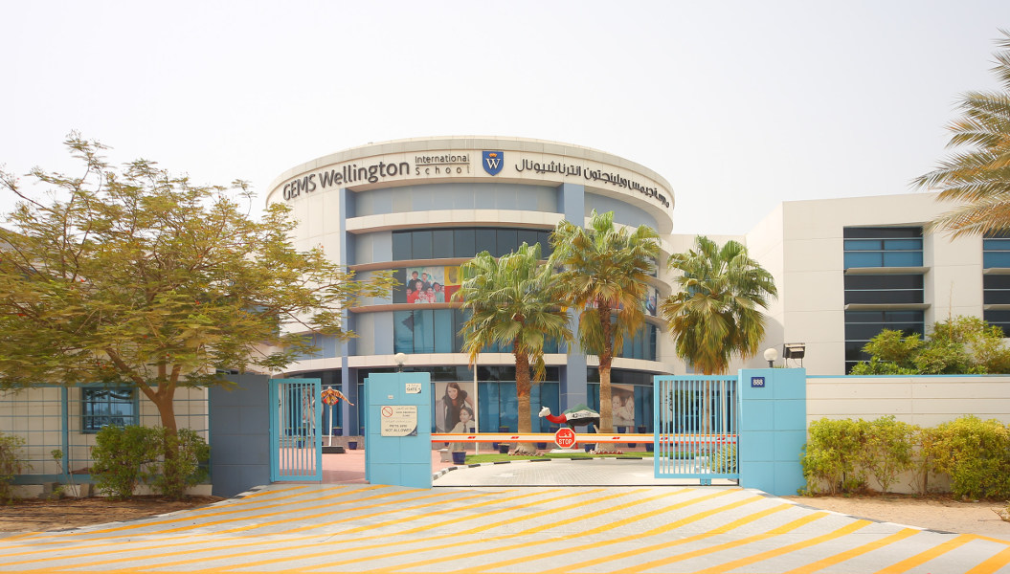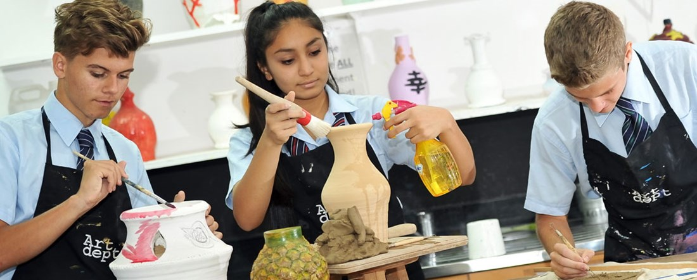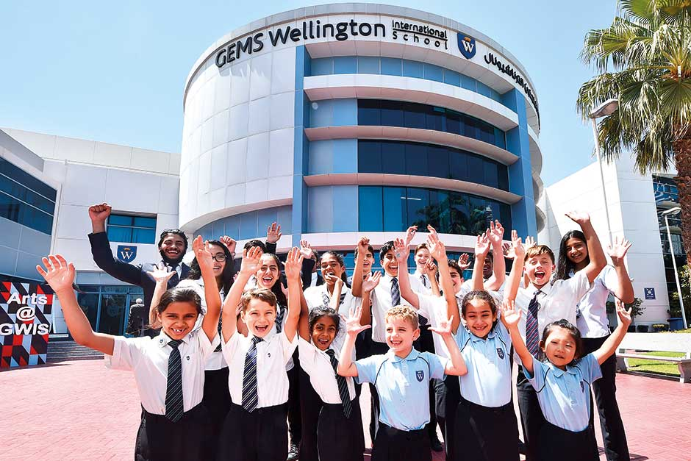

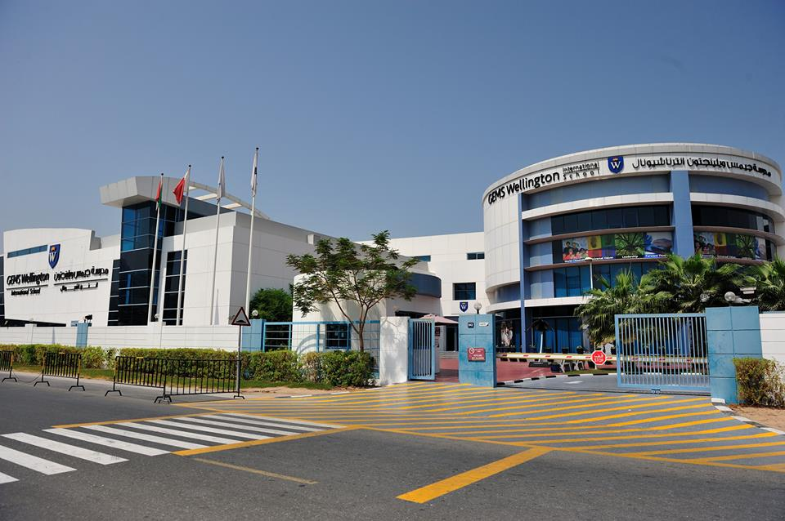

School system: English system+IB system

Current rating: Outstanding

Enrollment grade: FS1-13 grade

Tuition fee: AED 43941~95597

Address: Al Sufouh 1- Dubai

GEMS Wellington International School was founded in 2007 and has a truly groundbreaking learning environment that provides a high level of education for all students. The school covers an area of 8 acres and provides a range of facilities and resources, combining world-class education with unique and state-of-the-art infrastructure. GEMS Wellington International School is an open and inclusive international school that has been recognized as outstanding by KHDA for several consecutive years since 2009.

**Course settings**

GEMS Wellington International School offers the English national curriculum from the basic stage to 11th grade, as well as the International Baccalaureate preparatory courses, curriculum, and career planning for 12th and 13th grades, making it a leader in the development of courses in the UAE and internationally. Our curriculum is committed to providing every child with rich and innovative learning opportunities. Our course mastery methods ensure that all learners develop profound and sustainable knowledge to apply their learning across a range of backgrounds. We provide learners with a dynamic and creative learning environment that encourages challenges, stimulates curiosity and interest.

**The early stages of WIS**

Lower grade schools run from FS grade to 4th grade. Our unique "three school model" begins in the lower grades, and our students begin their learning journey at the basic stage. Continuing their journey to lower grades, our students enter grades 1-4, where they follow the English national curriculum.

The lower grades cover all seven learning areas specified in the early foundational curriculum in England, namely: communication and language; Physical development; Personal, social, and emotional development; Literacy; Mathematics; Understand the world; Performance Art and Design

Grades 1-4: English, mathematics, and science are very important and are considered core subjects in lower grades, combining our Arabic and Islamic courses. In addition, there are also familiar non core themes; Art, computer science, modern foreign languages, humanities, music, drama, and sports.

**Middle School Stage of WIS**

Students enter high schools at GEMS Wellington International School and begin to interact with subject experts in various fields of their studies. This transition period is a very important part of our student learning journey, which is why we offer holistic courses that promote a love for learning.

**Advanced stage of WIS (Key Stage 4: GCSE Course)**

10th grade marks the beginning of critical stage 4, marking the seamless transition of many of us students from 9th grade on a two-year GCSE journey. There are over 24 GCSE subjects for students to choose from, and we do meet everyone's needs. From art and photography to economics and astronomy, our aspiration is to provide the right path for every child.

**IB Course of WIS (Key Stage 5: International Diploma)**

The IB international curriculum is internationally recognized as a university admission qualification and is an intensive transitional stage between high school education and the demand for higher level independent learning in universities. At GEMS Wellington International School, IB Diploma Program (IBDP), IB Career related Program (IBCP), and course plans are offered.

IB Diploma Program (IBDP): Students are required to study six courses, which are evaluated through a combination of course assignments and external exams. Each of the 6 subjects studied is scored on a 1-7 point scale, allowing students to obtain a maximum IB score of 6 out of the 42 subjects they have taken

IB Career Related Courses (IBCP): Choices for grades 12 and 13: Business IBCP and Creative Media IBCP. The admission requirement for Business IBCP is 5 GCSESAT levels or above, including mathematics and English language; The admission requirements for Creative Media IBCP are GCSES level 4 or above, including mathematics and English language.

**Vocational education and guidance**

CEG is a planned activity plan provided in the curriculum that enables students to identify their strengths, skills, aspirations, and dreams, so that when they have to make decisions about the next steps (such as GCSE subjects, sixth grade choices, and universities), they can make wise choices that suit them.

**extracurricular activities**

GEMS Wellington International School offers a wide range of activities to enrich students' educational experience. For example, performing arts, creative subjects, and media, etc. Students can also participate in sports activities with entertainment and competitive goals, including rugby, basketball, and fitness. In many sports, as long as students are willing, they can participate in competitions, including football, tennis, and swimming, and there are also many successful GWIS sports teams in local leagues and international competitions. The school has advanced sports facilities, including a fitness studio, a large multifunctional sports hall, tennis and volleyball courts, a 25mm indoor swimming pool, an outdoor swimming pool, and climbing walls.

**tuition**

Application fee: 500 dirhams

PK tuition fee: 43941 dirhams

K tuition fee: 55346 dirhams

First grade tuition fee: 55346 dirhams

Tuition fee for 2nd grade: 55346 dirhams

3rd grade tuition fee: 55346 dirhams

4th grade tuition fee: 55346 dirhams

5th grade tuition fee: 55346 dirhams

6th grade tuition fee: 55346 dirhams

7th grade tuition fee: 76312 dirhams

8th grade tuition fee: 76312 dirhams

9th grade tuition fee: 76312 dirhams

10th grade tuition fee: 85870 dirhams

Tuition fee for 11th grade: 85870 dirhams

Tuition fee for 12th grade: 95597 dirhams

Tuition fee for 13th grade: 95597 dirhams

Scholarship: Provided

**Application Information**

Visa support: not provided

School start date: September

Other enrollment dates: enrollment at any time

Application deadline: Apply at any time

Grade for accepting new students: PK-13

Is admission based on academic performance: No

Admission waiting list: Usually there are

Application materials and requirements:

- Transcripts from the past two years

- Passport scanned copy

Email: registrar_wis@gemsedu.com

Phone:+97143484999

Application webpage (in English): http://www.wellingtoninternationalschool.com/admissions/

# Jumeirah College

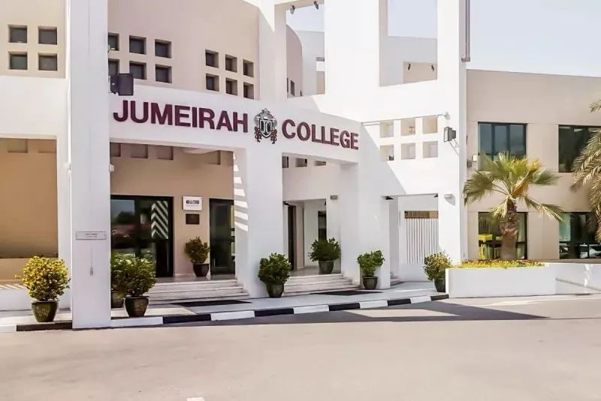

School system: English system

Current rating: Outstanding

Enrollment grade: grades 7-13

Tuition fee: AED 75178-93972

Address: 19th St - Al Safa - Al Safa 1- Dubai

**School Introduction**

Jumeirah College (JC) is an outstanding British school in Dubai that develops every student not only academically, but also socially, physically, and emotionally. Schools do not compare students to the average benchmark, but instead focus on understanding students as learners and individuals, exploring and embracing every opportunity, encouraging and supporting their learning and growth. The school has students from over 59 countries and is a truly global minded international school. Schools instill these values in students and shape them into successful, well-rounded, and open-minded international citizens of the 21st century. We provide a national curriculum for grades 7 to 13 in the UK, registered with the Department of Education and Skills in London, and serve as the corresponding examination center for the UK Examinations Committee.

Our vision is to create a vibrant learning community, cultivate happy, confident, and accomplished students, and surpass limits through a commitment to academic and personal excellence.

**Principal's message**

Welcome Message from the Principal/CEO

Mr. Nicholas Brain

Welcome to Jumeirah College, a place of exceptional educational experience where academic excellence, personal growth, and global citizenship blend together. As the principal of this wonderful institution, I am honored to introduce you to our vibrant community, where we cultivate a love for learning and empower students to realize their full potential.

At Jumeirah College, we believe that education transcends the walls of the classroom. We are committed to cultivating well-rounded individuals who not only possess knowledge and skills, but also possess values and character that have a positive impact on the world. Our educational philosophy revolves around comprehensive development, including academic rigor, creativity, critical thinking, and social responsibility.

As a member of the GEMS education family, Jumeirah College adheres to the highest standards of educational excellence. Our dedicated faculty and staff are composed of experienced and passionate educators who inspire and motivate students to pursue excellence. With their unwavering support, encourage students to explore their interests, pursue their passions, and confidently embrace challenges.

Our academic courses aim to challenge and attract students at every level, ensuring that they establish a solid foundation in core subjects while offering a wide range of educational options to meet individual interests. We cultivate a culture of curiosity, innovation, and independent thinking, providing students with the skills they need to succeed in a constantly evolving world.

In addition to academic pursuits, we offer a diverse range of extracurricular activities to encourage students to discover their talents and explore new areas of interest. Whether through participation in sports, music, drama, community service, or leadership opportunities, our students can cultivate valuable life skills and learn the importance of cooperation, resilience, and empathy.

At Jumeirah College, we also recognize the importance of cultivating global awareness and understanding. Our multicultural environment celebrates diversity, promotes cultural exchange, and prepares our students to become responsible global citizens. We encourage them to embrace different perspectives, develop cross-cultural skills, and participate in service programs to bring positive impacts to our local and global communities.

We believe that education is a collaborative effort between students, parents, and educators. Let's embark on a transformative journey together, unleashing your child's true potential. Join us at Jumeirah College, where we strive for excellence, inspire passion for learning, and prepare students for a successful and fulfilling future.

Nick Blaine

Principal/CEO

**Teaching quality**

Teacher student ratio: 1:12

The proportion of international A Level obtaining A * or A: 41%

The proportion of international GCSE obtaining A * or A: 66%

UAE government rating: Outstanding

**Course Introduction**

British Curriculum

Providing world-class education based on the carefully designed National Curriculum (NCfE) in the UK.

Jumeirah College offers UK national courses taught by fully qualified and experienced staff. This school has earned the deserved reputation for its high academic level. Students at Jumeirah College have achieved high scores in external assessment tests and exams at all levels.

Student groups are multicultural, with members from over 59 countries. However, most students hold a UK passport and all courses are taught in English. Students will prepare for the critical stages of sat, GCSE exams, AS and A2 levels, and ultimately enter the university of their choice. While maintaining a sharp academic focus in the college, we also strive to cultivate well-rounded students who are prepared for opportunities, responsibilities, and experiences in life.

Registration Examination Center

Jumeirah College is registered as an overseas school by the London Department of Education and serves as the examination center for all examination committees in the UK.

Recognized achievements

Throughout the college, we seek opportunities to recognize and celebrate the achievements of our students. Excellent grades, subject awards, certificates, hard work certificates, trophies, trophies, and medals all ensure that as many students as possible receive tangible rewards for their efforts and achievements.

Personal attention

In all grades of Jumeirah College, students receive individual attention to help them realize their potential. This is accomplished through various methods, including personal assessment and setting personal goals, using learning support assistants, form mentors, and differentiated work as appropriate.

Target setting

Jumeirah College is at the forefront of educational practice, using evaluation and testing information to set goals for each student and regularly track their progress. This strategy provides students with strong motivation and helps them understand the importance of striving towards specific goals. Parents and teachers also have a realistic foundation to evaluate the progress and achievements of each student.

Service standards

In an open and friendly environment, parents receive priority attention and promote open communication between the college, parents, and students. The frontline staff always provide information and assistance to parents, and make every interaction with the college enjoyable.

Learning support

The learning support department provides a range of support for students with a wide range of learning styles and challenges. Our learning center is located at the center of the college to reflect our philosophy of integration and personal support. All students with special learning needs have our teaching team and learning support assistants to solve their difficulties.

**Extracurricular activities**

Developing skills in new ways

Jumeirah College is developing skills in a new way. At Jumeirah College, students participating in extracurricular activities is equally important as their academic performance. By participating in these activities, students have enriched their campus life. In addition to physical development and exploration of interests, students are stimulated by learning challenges and competition, the importance of focus, teamwork spirit, and a sense of achievement. Jumeirah College provides a variety of extracurricular activities to support students' comprehensive development and provide opportunities for them to develop their talents and explore new interests. The activities include a wide range of personal pursuits and team building activities for all students to choose from.

Duke of Edinburgh International Award

The Duke of Edinburgh International Award encourages young people to learn new skills, actively exercise, volunteer in the community, and discover a sense of adventure outside of the classroom. It provides opportunities for young people to unleash their potential and prepare for their world, no matter what it may be.

Using the award framework and with the support of adult volunteers, young people develop their own customized plans as they strive to win internationally recognized bronze, silver, and gold awards.

Participants need to complete the skills, sports and entertainment, volunteer service, and adventure sections in order to win the award. In addition, gold medalists must also complete a residential section.

At Jumeirah College, international awards are fully integrated into school life, encouraging students to start receiving bronze awards in 10th grade, silver awards in 11th grade, and gold awards in 6th grade. We are one of the largest suppliers in the United Arab Emirates, with approximately 250 participants and 10 adults receiving comprehensive training to provide support.

**tuition**

Application fee: 500 dirhams

7th grade tuition fee: 72988 dirhams

8th grade tuition fee: 72988 dirhams

9th grade tuition fee: 72988 dirhams

10th grade tuition fee: 82112 dirhams

Tuition fee for 11th grade: 82112 dirhams

Tuition fee for 12th grade: 91235 dirhams

Tuition fee for 13th grade: 91235 dirhams

**Application Information**

Visa support: not provided

School start date: September

Application deadline: Apply at any time

Grades accepting new students: 7-10, 12

Is admission based on academic performance: No

Application materials and requirements:

- Transcripts from the past two years

- Recommendation letter

- CAT testing

- Passport scanned copy

Exam scores: GCSE achieved B in 4 subjects and C in 2 subjects

Email: registrar_jcd@gemsedu.com

Phone:+97143955524

Application webpage (in English): <http://www.gemsjc.com/admissions/>

# Jumeirah English Speaking School

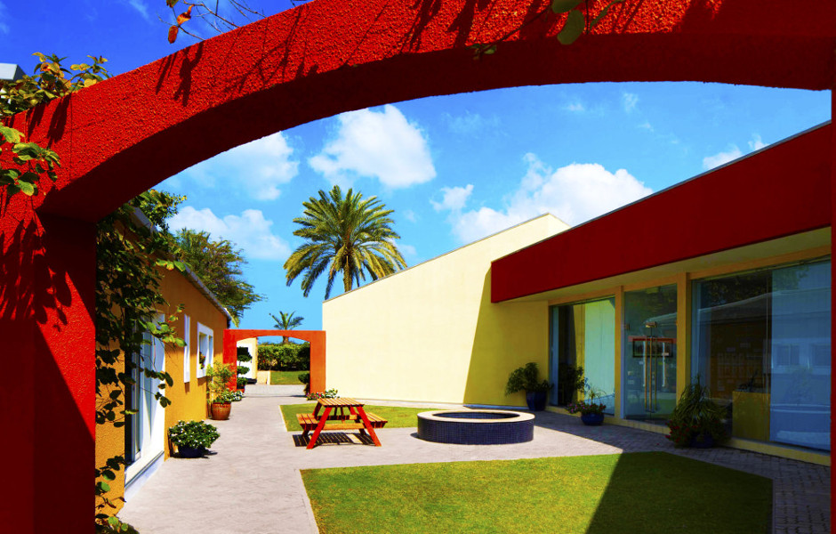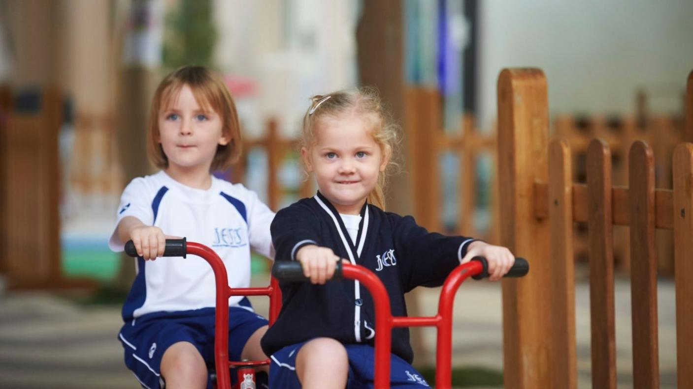

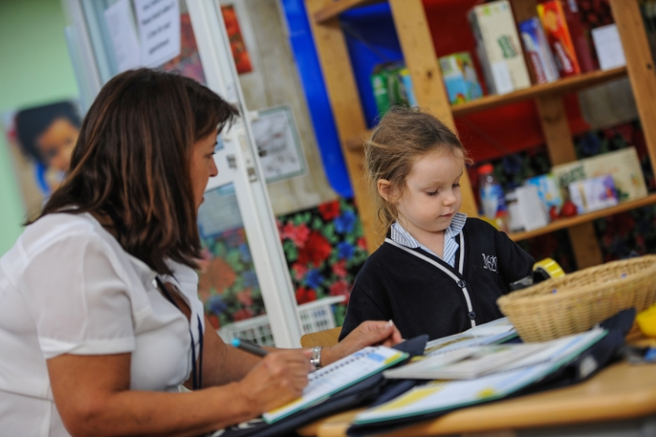

**Basic information of the school**:

School English Name: Jumeirah English Speaking School

Abbreviation: JESS Jumeirah

School system: UK

Current rating: Outstanding

Enrollment grade: 3-11/Foundation Stage 1 to Year 6

School bus fees: The official website query was unsuccessful.

Entrance exam: 500 dirhams (non refundable) Note: An additional registration fee of 100 dirhams (non refundable)

Tuition fee: FS1: 39030 dirhams per year/FS2 Year 6: 48231 dirhams per year

Address: Jumerirah Safa – P.O.BOX: 24942

**School Introduction**

JESS Jumeirah English School has a history of over 40 years and is a mature IAPS school. The excellent reputation of Jumeirah English School has spread throughout the Middle East and even further regions. During the more than forty years of education, Jumeila English School has achieved significant achievements in academic, music, sports, and performing arts fields. Currently, the school has over 700 students aged between 3 and 11.

**Course settings**

The grade setting of JESS Jumeirah English School is divided into three levels: FS/KS1/KS2.

1. Foundation Stage

The basic stage lasts for 2 years, namely basic stage 1 and basic stage 2, recruiting children over three years old.

There are a total of four classes in Foundation One and Foundation Two. Each class has well-equipped and spacious activity areas. Try to keep the class size below 22 people. Teaching is jointly completed by teachers and teaching assistants, while professional courses such as music, computer science, and physical education are taught by professional teachers.

The course learning environment has sufficient resources and provides students with various sensory activities. In all courses, the presentation section is particularly important to celebrate children's achievements in all areas of the curriculum.

Students have dedicated indoor and outdoor activity areas. The activity area provides them with a series of learning opportunities. Basic 2's computer, music, and physical education classes all have dedicated and well-equipped classrooms.

Course:

The basic curriculum for early childhood mainly follows seven learning areas. The focus of the entire basic stage is to enable children to learn first-hand learning experiences, with a strong emphasis on playing and early communication skills. In addition, traveling and visiting serve as an opportunity to enrich the curriculum. Similarly, tourists with special skills and experience will also be invited to attend classes.

2. Key Stage 1 (KS 1: Year1-2)

After completing the basic stage, students enter the critical stage 1 of learning. Key Stage 1 includes a 2-year (Year 1-Year 2) course that enrolls children aged 5 to 7. Like the basic stage, in critical stage 1, each grade has 4 classes, each with fully equipped and spacious activity areas. Each class should have a maximum capacity of 22 people. Teaching is jointly completed by teachers and teaching assistants. Professional courses such as music, computer science, physical education, and Arabic are taught by professional teachers.

The course learning environment has sufficient resources and provides students with various sensory activities. In all courses, the presentation section is particularly important to celebrate children's achievements in all areas of the curriculum.

Students have a dedicated activity area. The activity area provides a range of high-quality climbing equipment, anti fall safety surfaces, and a range of other activity facilities, ensuring that their rest time is meaningful! Computers, Arabic, music, and sports all have professional and well-equipped classrooms.

The rest period for critical stage 1 is from 10:45 am to 10:45 pm and from 12:30 pm to 15:15 pm. During break time, children have the opportunity to play and have lunch bento.

Course:

During the smooth transition between the basic stage and critical stage 1, the course structure is as follows:

core curriculum

English, Mathematics, Science, and Arabic

basic course

History, Geography, Design Technology, and Art

Note: Computer, Arabic, music, and physical education courses are taught by experts.

Maximize the connection between courses. All activities are carefully designed and closely linked to real-life experiences, catering to students with different learning styles. If given the opportunity, students will also participate in extracurricular activities to enrich the course content. Similarly, the classroom invites tourists with special skills and experience.

3. Key Stage 2 (KS2: Year 3-6)

After completing critical stage 1, students enter critical stage 2. Key Stage 2 includes a four-year period from third grade to sixth grade (ages 7-11). In grades 3, 4, 5, and 6, there are a total of 4 classes in each grade. Each class has well-equipped and spacious activity areas. Each class should have a maximum capacity of 22 people. Each learning environment has sufficient resources and provides students with a series of multisensory activities. In all courses, the presentation section is particularly important to celebrate children's achievements in all areas of the curriculum.

Classroom teachers are key figures in every student's school life, responsible not only for teaching subjects but also for the overall education of students. At the same time, starting from fifth grade, students will have their computers, music, library, Arabic, and physical education taught in French, which will enhance their confidence.

The rest period for this stage is from 9:30am to 10:00am and from 11:45pm to 12:30pm. Students have a dedicated outdoor play area that offers a range of activities, and at this stage, they have a playground that provides opportunities to participate in team activities.

Course:

core curriculum

English, Mathematics, Arabic, and Science

basic course

History, Geography, Design Technology, and Art

Note: At this stage, the use of the internet, queries, challenges, and real-life learning have been included in all courses.

Try to add travel and special activities to enrich the course as much as possible. For example, sixth grade students have a three night trip to Dibba. A fifth grade student has an Al Dhaid trip for one night. Fourth grade held an overnight Viking camp on the school playground. These activities provide them with excellent opportunities to participate in practical activities in real life. We provide a caring and dynamic learning environment, aiming to cultivate confident and happy children with learning interests.

extracurricular activities

JESS supports the concept of education exceeding classroom limitations. Therefore, the scope of extracurricular activities for children in third grade and above varies. Extracurricular activities are rich in content and tailored to students' professional knowledge and interests. For students, they will have the opportunity to experience new areas of activity and develop into individuals who may surpass their school age.

**tuition**

Application fee: 100 dirhams

PK tuition fee: 39837 dirhams

K tuition fee: 49230 dirhams

1st grade tuition fee: 49230 dirhams

Tuition fee for 2nd grade: 49230 dirhams

3rd grade tuition fee: 49230 dirhams

4th grade tuition fee: 49230 dirhams

5th grade tuition fee: 49230 dirhams

6th grade tuition fee: 49230 dirhams

7th grade tuition fee: 82521 dirhams

8th grade tuition fee: 82521 dirhams

9th grade tuition fee: 82521 dirhams

10th grade tuition fee: 82521 dirhams

Tuition fee for 11th grade: 82521 dirhams

Tuition fee for 12th grade: 93852 dirhams

Tuition fee for 13th grade: 93852 dirhams

Registration fee: 500 dirhams

Refundable deposit: 20000 dirhams

**Application Information**

Visa support: not provided

School start date: September

Other enrollment dates: enrollment at any time

Application deadline: Apply at any time

Grade for accepting new students: PK-13

Is admission based on academic performance: No

Admission waiting list: Usually there are

English requirement: Good

Phone:+97143619019

Application webpage (in English): <https://www.jess.sch.ae/admissions/can-i-apply->

# Dubai College

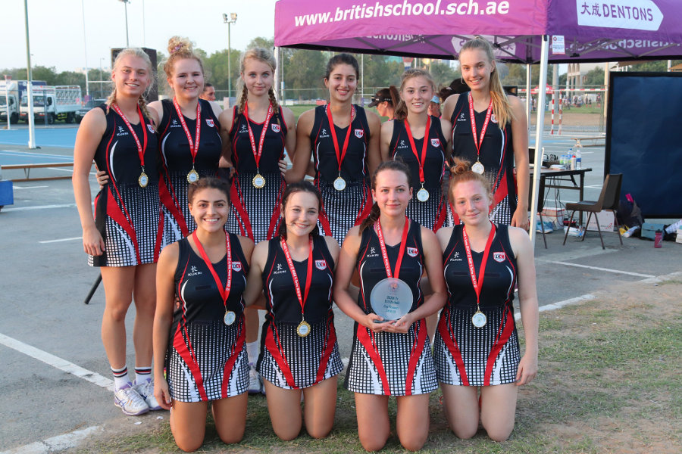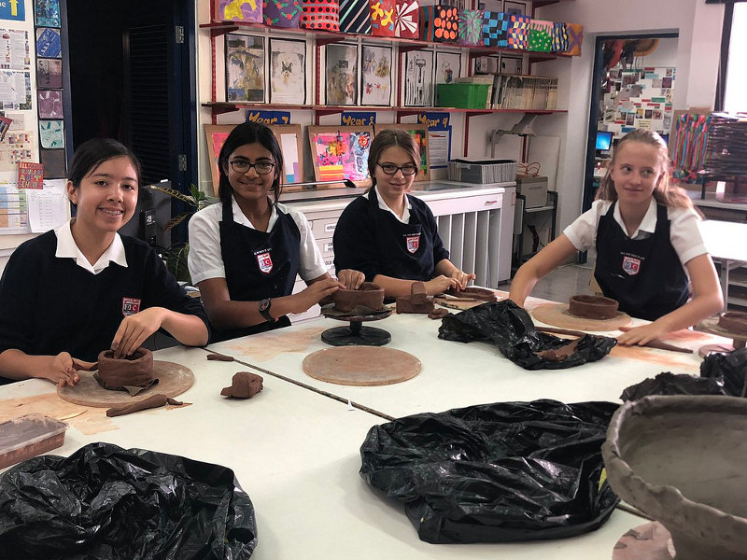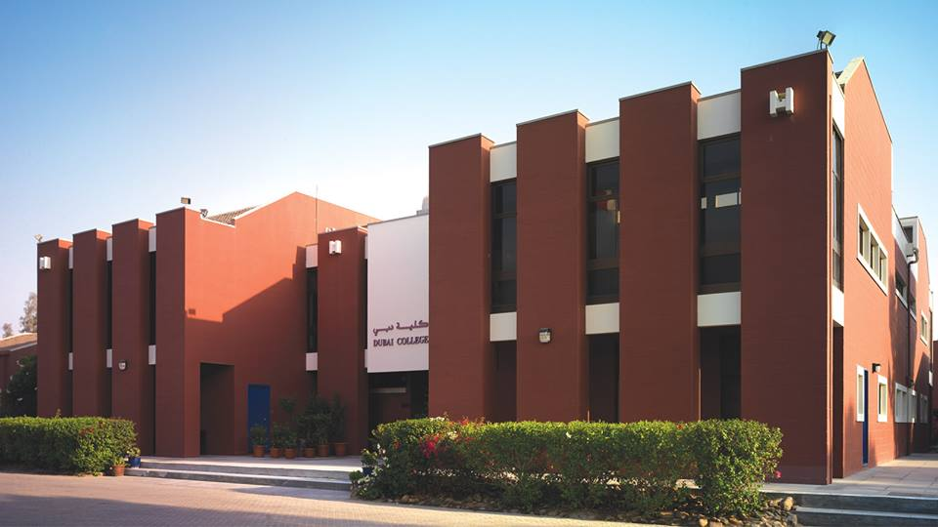

School system: English system

Current rating: Outstanding

Enrollment grade: Year 7-Year 13

Tuition fee: Year 7-11- AED26936

Year 12-13-AED30501

Address: Al Sufouh, Dubai, 30 minutes drive from International City

**School Introduction**

Dubai college was established in 1978 and is recognized as one of the top British schools in Dubai. As a non-profit educational institution in Dubai, Dubai college not only focuses on students' academic performance, but also emphasizes the development of their moral, intellectual, physical, and aesthetic abilities, active participation in charitable activities, and the cultivation of creative thinking. Dubai college welcomes students from different countries and ethnicities and provides the highest quality British education for students aged 11-18.

Dubai college is one of the top 12 outstanding schools in Dubai. The 76893 square meter campus is located in Al Sufouh 1, Dubai, providing students with the most advanced conditions and convenience facilities. The school adopts British education and provides students with GCSE (General Certificate of Secondary Education) series of courses and short-term ICT (Electronic Computer Technology) courses. The school's test results in 2016 showed that the school achieved an excellent rate of 66.1% and a pass rate of 94% in the ALEVEL (Advanced Level of General Diploma of Secondary Education) exam, which is much higher than the average level in the UK. The test results in GCSE were also good, with an excellent rate of 82.1% and a pass rate of 99.9%, making Dubai college one of Dubai's top schools.

**Course settings**

Dubai college enrolls students throughout the year, with a three-year academic year. The academic year is set from September to July of each year. The student's curriculum consists of core courses and optional courses.

Year7-11

In secondary school, all current students will need 10 GCSEs. In addition, all students will receive personal, social, and healthy education in the form of enriched daily, digital skills courses, and games. The core GCSE course consists of the following subjects:

1. Mathematics 2. English Literature 3. English 4. Biology 5. Chemistry 6. Physics 7. Islamic Studies (Muslim Students)

To encourage balanced courses, students choose four optional courses, which must include:

Arabic, French or Spanish

Business research, computer science, economics, geography or history

Art, Design and Technology, Drama, Latin, Music or Sports

Year12-13

The vast majority of students choose to study the four subjects of A Level at the beginning of 12th grade. About half of the students will give up one of the courses and only study three subjects at Year13. The disciplines offered by A level include:

Latin, French, English literature, Spanish

Art, Music, Drama, Sports

Biology, Chemistry

Economics, Mathematics, Advanced Mathematics, Physics

Design and Technology

Geography, Government and Politics, History

All students in the Sixth Form (the highest grade of a British high school) must undergo project training and participate in the PSHE program in the form of enrichment days to prepare for life challenges after graduating from Dubai college. Islamic education is also included in the compulsory education for Muslim students in Year 12.

Admission requirements: Year7-Year10

1. Language requirements: As the teaching language of Dubai college is English, all students must have fluent English speaking and good writing skills.

2. Ability requirements: As a school that places great emphasis on academic development, Dubai college adheres to a flexible and selective admission policy. 7th grade students (if possible, may be selected as 8th or even 9th grade) will be required to take English and mathematics assessments as well as cognitive ability exams. Only students who demonstrate good abilities in all three aspects of evaluation will be admitted to the school.

3. Report requirements: Dubai college requires previous reports from primary or other schools to help schools select students who have comprehensive development in morality, intelligence, physical fitness, aesthetics, and creative thinking. In addition to fluent English speaking and good reading and writing abilities, Sixth Form students must also have a good GCSE or an equally important exam score report, requiring them to have at least 6 A/A * (7/8/9) grades, including English and mathematics.

**Extracurricular activities**

Dubai college offers a wide range of after-school activities, including sports such as football, cricket, tennis, music singing and recording activities, science design exhibitions, and more, to satisfy students' thirst for knowledge and exploration. Dubai Public School also participated in the Duke of Edinburgh Award Program, Youth Entrepreneurship Program, and F1 Student Design Competition. The organizers of various after-school activities are professional teachers or professional coaches and guidance hired outside the school.

**Teaching quality**

Teacher student ratio: 1:9 International A level exam pass rate: 96.4%

59.9% of international A Level students receive A * or A, and 99.67% pass the international GCSE exam

The proportion of international GCSE obtaining A * or A: 88.17%. UAE government rating: Outstanding

**tuition**

Application fee: 525 dirhams

7th grade tuition fee: 82482 dirhams

8th grade tuition fee: 82482 dirhams

9th grade tuition fee: 82482 dirhams

10th grade tuition fee: 82482 dirhams

Tuition fee for 11th grade: 82482 dirhams

Tuition fee for 12th grade: 93399 dirhams

Tuition fee for 13th grade: 93399 dirhams

Refundable deposit: 25000 dirhams

**Application Information**

Visa support: not provided

School start date: September

Grades accepting new students: 7-10, 12

Is admission based on academic performance: Yes

Admission waiting list: Usually there are

English requirement: Good

Application materials and requirements:

- Entrance Examination

Exam score: GCSE achieved A in 6 subjects

Email: admissions@dubaicollege.org

Phone:+97143999111

Application webpage (in English): <https://www.dubaicollege.org/join-us/admissions>

# GEMS Jumeira Primary School- Dubai

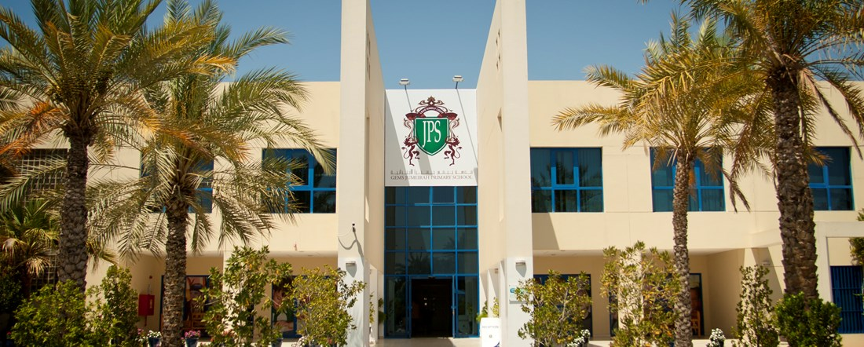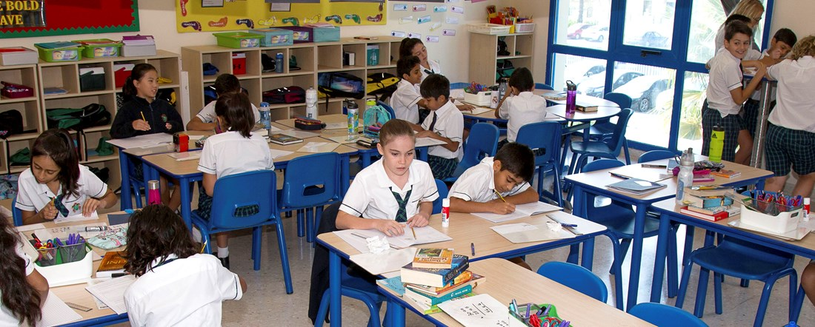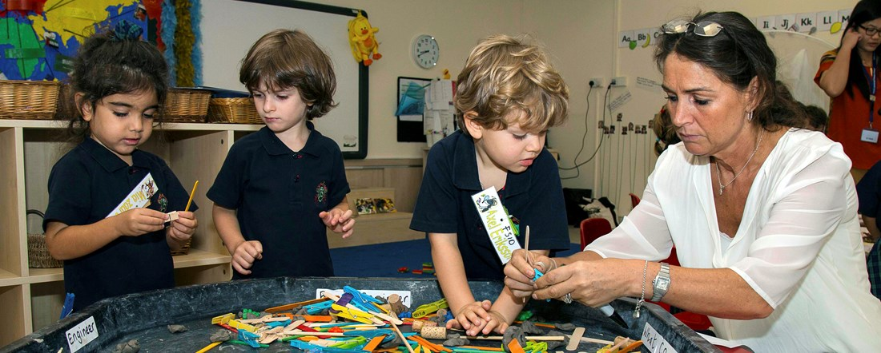

School system: UK

Location: Street No. 19, Al Safa 1- Dubai

Academic Year: Primary School

Teaching system: EYFS, UK National Curriculum

Annual tuition fee: AED 40865-51511

GEMS Jumeira Primary School, located in Jumeirah District 3, is one of the most popular elementary schools in the Emirate and has been recognized as an excellent elementary school by KHDA since 2010. The school provides customized innovative courses, with a focus on British courses, while also incorporating best practices from other international courses.

Details: Homes of 1470 students, JPS has been rated as the "best" school by KHDA for 9 consecutive years. Although the school may appear small on the outside, the interior space and appearance look completely different. Each grade is evenly divided, and even outdoor activity areas are carefully arranged and controlled. The school itself is described by the parents of students as "very enthusiastic and caring" and "very inclusive", saying that the school has a "primary school atmosphere". There are students from over 70 different countries on campus. 99 full-time teachers (mainly British) and almost equally many (87) teaching assistants provide support to students. The turnover rate of teachers is far below the average level of 20-22% in Dubai. The average class size ranges from 22 students (basic stage) to 27 students (grades 1-6). However, the 1:15 teacher-student ratio has not changed much in recent years, ensuring sufficient attention to each child. The staff includes speech and language occupational therapists, three psychologists, and primarily focuses on the health and safety of students, parents, and faculty. JPS provides a customized course that focuses on deep understanding, preparing international student families for success in the constantly evolving future. The key knowledge, skills, and understanding provided by the school have been identified as the foundation for success in education, employment, lifelong learning, and personal development, and are integrated and taught in conjunction with the UAE Ministry of Education's Social Research and Ethics Education Program and JPS's Welfare Curriculum. Creative courses on campus can stimulate children's interest in learning and provide meaningful learning experiences, creating a dynamic, inclusive, and creative learning environment that encourages challenge, curiosity, and innovation. Students from grades 3 to 6 use the library twice a week, and the school provides online quizzes to ensure they understand the books they are reading. Students from grades 3 to 6 can also use science laboratories and STEAM classrooms, where they can develop their skills through robotics technology. The school also encourages students to showcase their musical talents through monthly Showtime, and the school also has regular music conferences. JPS students also performed at the Dubai Opera House and Shanghai Opera House during Evita performances. The school provides a variety of extracurricular activities, allowing children to develop in all aspects.

# GEMS Dubai American Academy

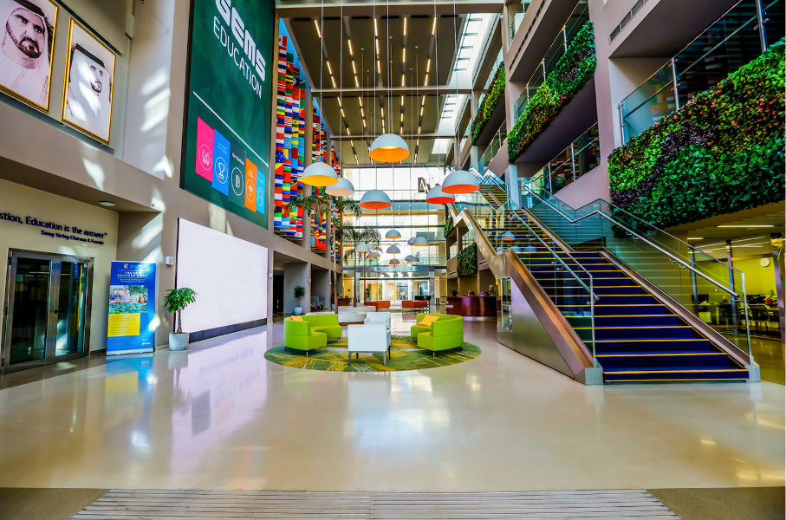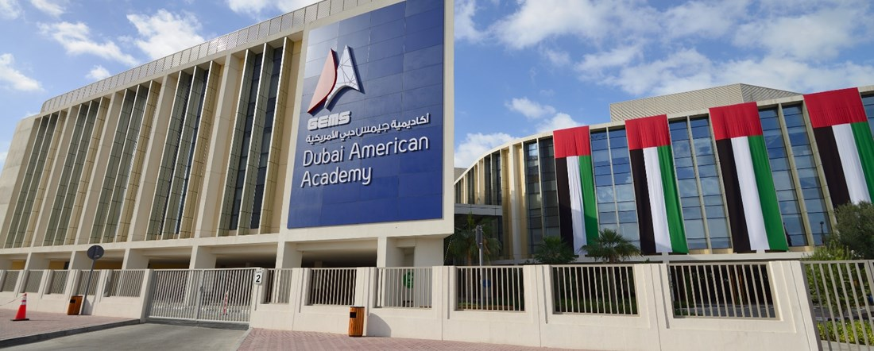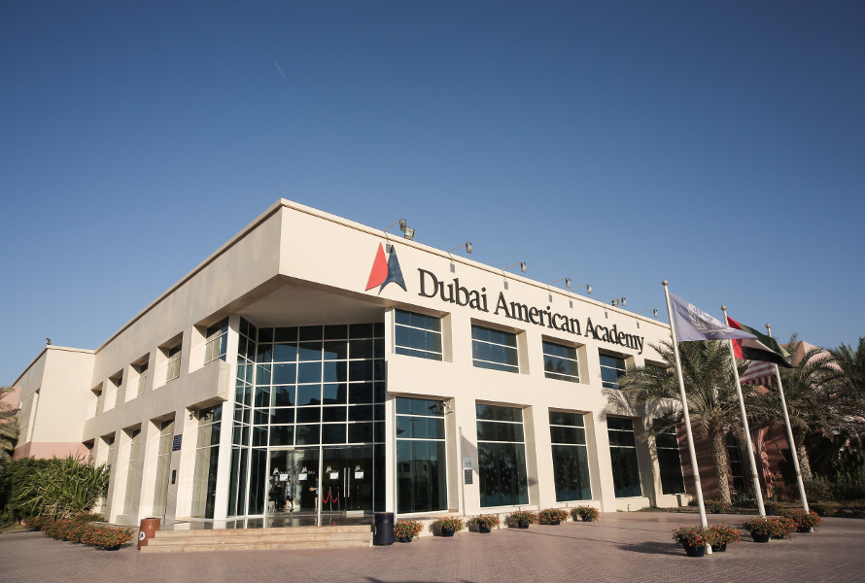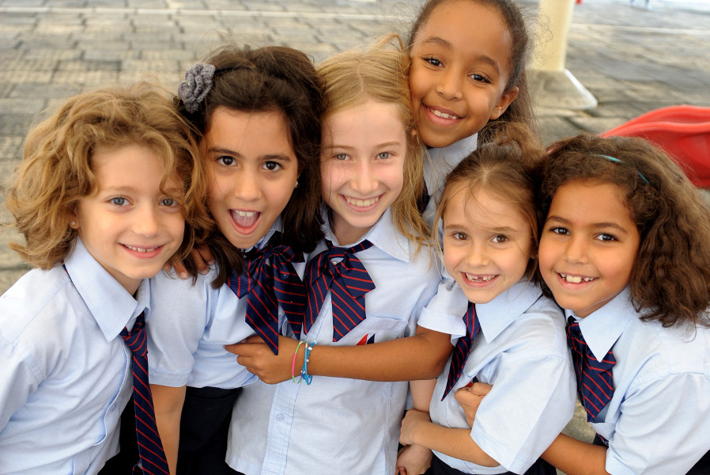

School system: US/IB system

Current rating: Outstanding

Enrollment grade: KG1-12 grade

Tuition fee: AED -63026-88848

Address: Hessa Street, Sheikh Zayed Rd, Dubai

**School Introduction**

GEMS Dubai American Academy (DAA) is the flagship American school of GEMS Education. DAA provides a rich range of American and international diploma programs to students from around the world, helping them prepare for success in the world's most prestigious universities and colleges.

DAA is the only US curriculum school in Dubai to receive a KHDA outstanding rating, and has been receiving this rating since 2011. DAA has a history of over 25 years and outstanding academic achievements, making it one of the most popular American schools in Dubai. The outstanding tradition of the school is combined with its future oriented curriculum, which focuses on creative design, cutting-edge robotics technology, and digital technology. Through teaching, learning, and innovation, students acquire a variety of reading and writing abilities and fluency levels to support true world-class learning, personal growth, and future preparation. DAA provides various extracurricular activities, sports, and leadership opportunities to enrich the comprehensive development of each student.

DAA employees teach and inspire excellent academic and lifelong learning skills through continuous review and construction of diverse American courses, improving student performance, encouraging integrity, and cultivating a desire to learn. The goal of DAA is to become a good citizen as follows:

·Respect and tolerance, celebrating diversity

·Aspiration and encouragement to pursue excellence

·Committed to the well-being of humanity and the environment

·Open minded, creative, flexible, and good at reflection

·Embrace and drive positive change with enthusiasm and determination

·Conduct in compliance with ethical standards and take responsibility for it

Join GEMS Dubai American Academy and embark on a journey of student development

**Principal's message**

Dr. Ethan Hildreth

Director/CEO

Dear parents,

At Dubai American Academy (DAA), our community is composed of classmates, faculty, and parents, and we encourage and love every student. Here, you will feel meticulous support and care, because we believe that only in this atmosphere can students freely pursue their dreams.

We are proud of our successful university admission rates and outstanding academic performance, which have enabled us to be at the forefront of education in Dubai and even globally. Our art, sports, and technological innovation projects also match it. Our goal is to provide students with the highest international standards, a rich range of American courses and international bachelor's degrees, aimed at inspiring them to explore innovation in the classroom and globally. Our friendly culture is the foundation of all success, and the interpersonal relationships that students establish here not only shape their personalities, but also change their lives.

DAA students have been inspired by their love for learning since childhood, and we guide them to explore, maintain curiosity, and enjoy the fun of scientific learning. At DAA, excellence means breaking personal limits. We help students develop their ability to adapt to changes and internalize the importance of growth, family, community, and world responsibility in the process of broadening their horizons. By the time we graduate, our students are ready to become innovators, outstanding thinkers, and dreamers. In short, they have become future leaders.

DAA is a stunning example that you must personally visit to fully experience. Welcome to join us, visit the venue and explore everything we offer!

**Course settings**

Kindergarten and Primary School

① I3 framework:

Inquiry: Through a process driven learning experience based on iNQUIRY and future fluency, students' learning experience is relevant, meaningful, and authentic.

Innovation: A wide variety of educational technology tools enable teachers to integrate drones, manual coding, and traveling the world through VR into learning. DAA's innovation creates a mindset, and our ED Tech enables students to fully enjoy the joy of focusing on the future.

INTEGRITY: The pride of a leopard. By actively strengthening and clarifying expectations and logical consequences, cultivate students' integrity. Proud of the school and oneself, adopting a positive attitude towards everything done, taking responsibility for one's own actions, and showing respect at school and home are the expectations of the school for Leopard.

② Course content

The core curriculum areas of reading, writing, mathematics, science, and social research adopt a focus on continuous progress. In addition to core courses, students also receive guidance on sports, music, art, Arabic for native and non-native speakers, Islamic education for Muslims, library science, and teaching techniques.

③ Student support:

English Language Learners (ELL)

To motivate each child to achieve outstanding academic success, DAA offers the English Language Learner (ELL) program, which uses a sheltered immersion model and WIDA programs (if applicable) to support ELL students in mainstream classrooms

Identification (SEND)

DAA provides an Inclusive Plan (SEND) for students in all grades who require additional support. This support aims to help students meet grade level standards and challenge and expand students who reach grade level or above in mainstream classrooms. The student support team provides planned accommodation, modifications, and teacher training and guidance.

Consulting services:

The primary school guidance program supports the academic, social, and personal development of each student. Counselors provide support to teachers and administrators to ensure that each student achieves success in both academic and behavioral aspects. Counselors work with students in the form of individuals, groups, and classes.

④ Activities and Sports

Activities (course length is usually one hour, once a week after school): art and craft, dance class, coding, drama, karate, world language, facial mask production, student union, yearbook, creative writing, music works

Competition: Second grade and above: Season 1- Football, Season 2- Athletics, Season 3- Basketball

Swimming team: 2nd grade - Development team, 2nd to 5th grade - Youth swimming team

⑤ 1:1 iPad project

Intended to demonstrate to students how to use iPads independently and effectively, the student union regularly participates in the "Everyone Can Program" course taught by the homeroom teacher.

middle school

① Student courses

The core of learning experience:

Development response: Based on the unique nature of adolescents, make all decisions related to school organization, policies, curriculum, teaching, and evaluation.

Challenging: Ensure that every student can learn and have high expectations for every member of the learning community.

Empowerment: Provide all students with the knowledge and skills necessary to take responsibility for their own lives, tackle life challenges, successfully operate at all levels of society, and become knowledge creators.

Fairness: Advocate and ensure the learning rights of each student, and provide appropriate challenging and relevant learning opportunities for each student.

② Subjects and Elective Courses:

Core disciplines: English, Mathematics, Social Studies, Science, Sports/Health, Arabic, and Islamic Education (for Muslim students).

Elective courses: Art, Coding and Robotics, Design and Technology, Drama, Music, French, Spanish, and Sports Research. Please note that 6th grade has the opportunity to try a series of elective courses, and then choose three elective courses to study in 7th and 8th grades.

③ Student welfare:

Student management: Students receive guidance and support through various levels of welfare to ensure that all members have staff available for assistance when needed, and to support them in making choices based on values related to community respect.

Secondary school tutoring:

·Review student records to assist in arranging and placing students from the beginning of the academic year.

·Regularly hold collaborative meetings with teachers, administrators, and parents to discuss the needs of students.

·Collect and analyze qualitative and quantitative data to determine and meet the needs of students.

·Provide students and families with information and support on adolescent development, educational goals, decision-making, interpersonal relationships, personal responsibility, and other skills necessary for high school students to become successful and productive global citizens.

·Provide prevention, intervention, and crisis response services to students and families. When necessary, our counselor will recommend external resources to students and families.

high school

① US/IB courses

Teaching language: English

Core courses: reading and language arts, mathematics, science, social research, Arabic for native and non-native speakers, Islamic education for Muslim students, health and physical education

Elective courses: such as digital video, visual and performing arts, and world languages.

② Sports activities

Season 1: Volleyball, Golf, Swimming, and Academic Competitions

Season 2: Basketball, Football, Off Road, Tennis, and Advanced Art

Season 3: Badminton, athletics, baseball, softball, forensic science, and youth art.

③ High School Student Union

Committed to providing leadership opportunities for students, serving schools and communities, and making their lives more enjoyable. Students in grades 9-12 are eligible to serve in the student union.

④ CAS

Representing creativity, activity, and service, it takes 70 hours to study CAS.

extracurricular activities

Student leadership

Students have many opportunities to develop their leadership skills in DAA and other places. Ambassadors, student union members, and student innovation teams welcome new members to join our community, participate in sustainable development plans, and share their knowledge through coding laboratories and seminars.

**External activities**

ESM and the Music and Arts Center (CMA) provide our students with a variety of courses, including physical education, art, science, music, and language courses.

Duke of Edinburgh Award

DAA, we are committed to promoting personal growth and independence. As part of its commitment to future development, DAA is proud to offer its students the prestigious Duke of Edinburgh Award program.

**Internal activities**

Kindergarten and Primary School Stage: Leading Leopard, Ball, Football, Rugby, Cricket Club, Science Club, Chess Club, Dance and Action, Arabic Reading, Sewing, Calligraphy Club, Mathematical Games, Mindfulness Art, Creating with Minecraft, Freeze Frame Animation, Cross stitch, Lego Blocks, Chorus Club, ES Video News Club, Innovative Arabic Project, IPAD, Chessboard Games, Quran Narrative, Creative Writing Club, Robotics, Table Tennis

Secondary school stage: Model United Nations, Fitness Club, Art and Crafts, Islamic Art, Origami, Podcast, Ukri Club, Short Film Club, 3D Printing, Arabic Homework Club, Book Club, Creative Writing, Ceramics, Harry Potter Crafts, Creative Expression, Creating Arabic Videos, Ultimate Frisbee, Touch Rugby

More activities: High school students can create and operate their own clubs under the supervision of teachers, as well as participate in student unions. DAA also offers a variety of sports and drama courses

sports

The year is divided into three activity seasons (autumn, winter, and spring), each of which provides a series of opportunities for our students. All sports and activities are provided by skilled, experienced, and enthusiastic coaches, helping our students achieve their personal best in any activity they choose. These activities include:

·UAE Youth Athletics Conference (Jr. EAC) (Grades 4-5)

·UAE Sports Council (EAC) (grades 6-8)

·MESAC (9-12 Grades)

·Water sports

Art

Primary school: Music and art are part of the professional subjects in primary school. In addition, elementary school students also participate in winter and spring concerts, and have the opportunity to participate in elementary school choir clubs, Yukrili clubs, or fifth grade productions.

Middle school: Middle school provides 2D and 3D art, including music and drama as part of the curriculum, and also offers students the option to participate in annual music production. High school choirs and bands hold regular concerts.

High school: High school students can utilize various art, music, and drama courses, including IB drama research. Students can participate in high school choirs, orchestras, and theatrical works, and have excellent opportunities to surpass the classroom and fully unleash their talents.

Creativity, Action, Service (CAS)

All high school students are required to participate in CAS courses and reach 70 hours

Creativity: Exploring and expanding ideas to generate original or explanatory products or performance

Action: Physical exertion contributes to a healthy lifestyle.

Service: Collaborate with the community and participate in mutual benefits to meet real needs.

Global Citizenship

Middle school: Week Without Walls

Students can participate in local and international travel, involving services, adventures, and culture.. These travels allow these teenagers to step out of their comfort zone and see real-world problems. The students returned from their WWW trip full of confidence, empathy, and a more comprehensive view of the world we live in, as well as ideas on how to make the world a better place.

High School: Career Centered Travel

Students have the opportunity to travel to Germany, Switzerland, and California for career centered overseas trips, or participate in on campus seminars focused on various fields such as entrepreneurship or innovation. 10th grade students also have the opportunity to participate in volunteer internships within or outside the United Arab Emirates. For example: The Landmark Group, Dubai City Government, MAG Clinic, Scality, and other companies.

# GEMS Modern Academy

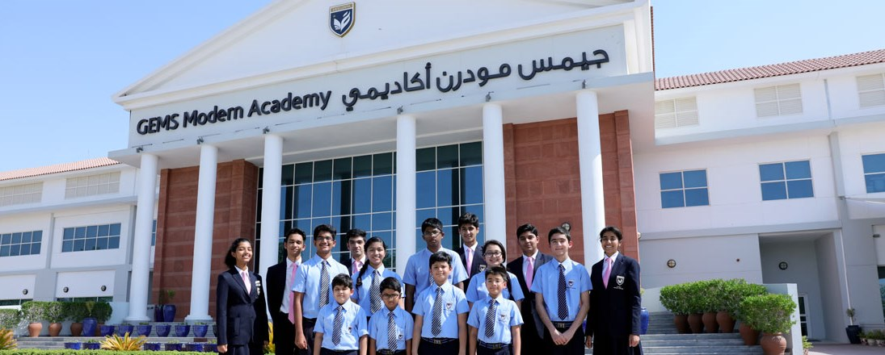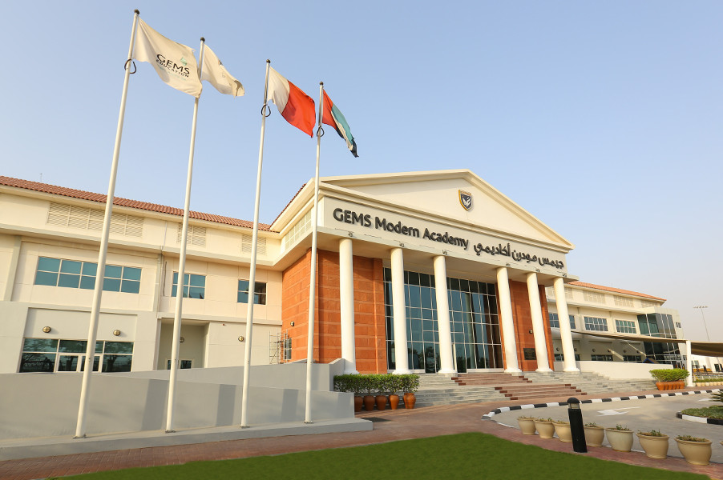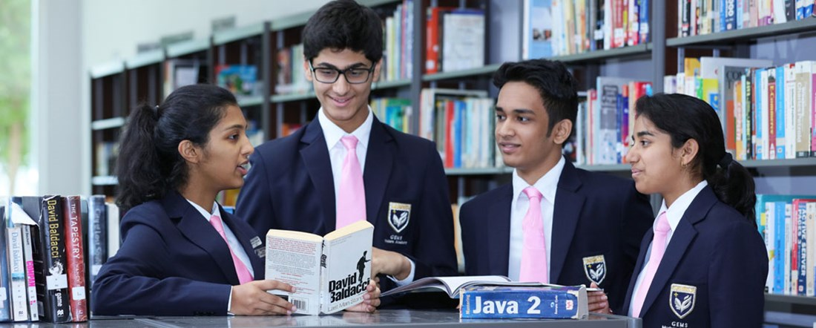

**School Introduction**

GEMS Modern Academy was founded in 1986 and is an Indian school in Dubai. It mainly provides Indian courses for preschool to 12th grade students and IBDP courses for 11th and 12th grade students. GEMS Modern College is the only Indian curriculum school rated as "outstanding" by the UAE government.

**Principal's message**

Head of School

"The ethos that has taken years to build at GEMS Modern Academy is palpable as soon as you enter the school, and even a case visitor cannot help but be drawn to the warmth and care that see to exclude from every corner."

Nargis Khambatta

**Basic information**

Year of establishment: 1987

Teaching language: English

Nature: Profit making

Number of students: 3939

International student ratio: over 50%

The largest student group: India

Dress code: School uniform

Geographical location: suburban areas of large cities

**Teaching quality**

Teacher student ratio: 1:17

IB average score: 33/45

Ratio of IB equal to or higher than 40: 8%

The proportion of IB equal to or higher than 35: 29%

The proportion of IB equal to or higher than 30: 71%

UAE government rating: Outstanding

**Academic courses**

Course type: IBDP

IB Personal and Social Subjects: Information Technology, History, Business Studies, Geography, Psychology, and Economics in a Globalization Society

IB Literature and Language Subjects: Hindi, French, English, Spanish, Arabic

IB Mathematics Subject: Mathematics Learning Standard Level (SL) Mathematics Standard Level (SL) Mathematics Advanced Level (HL)

IB Science Subjects: Physical Education, Training and Health Sciences, Chemistry, Physics, Biology, Social and Environmental Systems, Computers, Science

IB Art Subjects: Visual Arts, Music

**School culture**

We firmly adhere to traditional values and proudly promote excellent traditional culture. Our school has strict discipline and teachers and students respect and respect each other. We also clearly recognize that different students have different needs and abilities. Our vision is to cultivate all students into outstanding contributors to society.

**tuition**

Application fee: 500 dirhams

PK tuition fee: 35360 dirhams

K tuition fee: 35360 dirhams

1st grade tuition fee: 40044 dirhams

Tuition fee for 2nd grade: 40044 dirhams

3rd grade tuition fee: 42223 dirhams

4th grade tuition fee: 42223 dirhams

5th grade tuition fee: 44538 dirhams

6th grade tuition fee: 44538 dirhams

7th grade tuition fee: 44538 dirhams

8th grade tuition fee: 44538 dirhams

9th grade tuition fee: 47471 dirhams

10th grade tuition fee: 47471 dirhams

Tuition fee for 11th grade: 68302 dirhams

Tuition fee for 12th grade: 68302 dirhams

Scholarship: Provided

**Application Information**

Visa support: not provided

School start date: September

Other enrollment dates: enrollment at any time

Application deadline: Apply at any time

Is admission based on academic performance: No

Application materials and requirements:

- Transcripts from the past two years

- Entrance Examination

- Interview required

- Passport scanned copy

Email: info_mhs@gemsedu.com

Phone:+97143263339

Application webpage (in English): <http://www.gemsmodernacademy-dubai.com/admissions/>

# Dubai English Speaking College

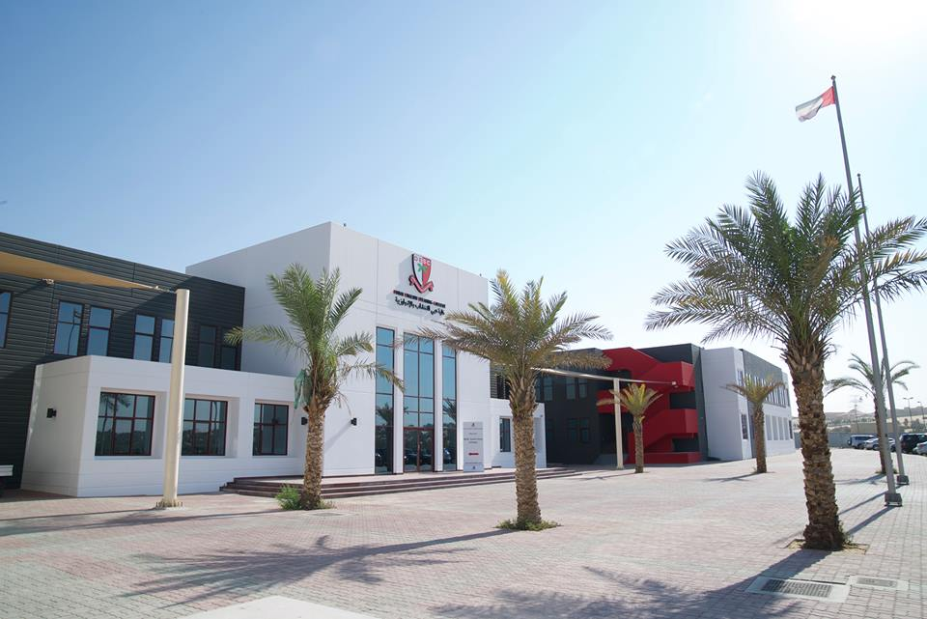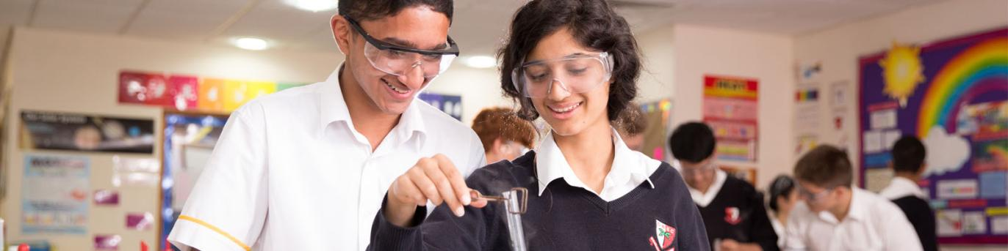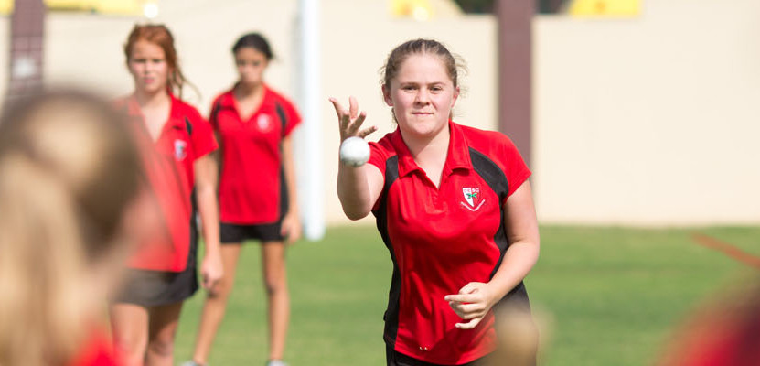

Education System: English

Current rating: Outstanding

Enrollment grade: Y7-Y13 (Sixth Form)

Tuition fee: 77782-83601 dirhams per year

**School Introduction**

Dubai English Speaking College is the oldest British school in the United Arab Emirates, founded in 1963 by former Dubai ruler Sheikh Rashid. The school is a non-profit organization managed by a council, so there is significant reinvestment in both the long and short term, ensuring excellent facilities. Dubai English Speaking College is one of the most mature schools in the United Arab Emirates and the first school to offer British courses. The goal of the school is to cultivate independent and confident students who can actively respond to challenges and unleash their potential. DESS aims to develop students with self-worth and mutual respect. These qualities are crucial for students when facing future challenges.

In 2006, DESS opened its own high school, Dubai English College (DESC), in the Academic City. The purpose of the school's establishment is to provide high-quality British education for students under the age of 18 and prepare them for entering university. DESC is only available to students in grades 7 to 13. This non-profit school does not select students on an academic basis. Since 2013, DSIB has consistently rated DESC as excellent, which was considered an impressive feat after its opening in 2007. The cost of DESC ranges from 78720 dirhams in the seventh to eleventh year to 84609 dirhams in the sixth grade.

**Principal's message**

"As a not for pro fit entity we are able to invest in the sole purpose of making our provision the very best that it can be, without competition."

Andrew Gibbs

**Basic information**

Year of establishment: 2005

Teaching language: English

Nature: Non profit

Number of students: 1514

International student ratio: over 50%

Number of student countries of origin: 60

Largest student group: UK

Dress code: School uniform

Geographical location: suburban areas of large cities

**Teaching quality**

Teacher student ratio: 1:12

International A level exam pass rate: 99.8%

The proportion of international A Level obtaining A * - C: 85%

International GCSE exam pass rate: 100%

The proportion of international GCSE obtaining A * or A: 38.7%

The proportion of international GCSE obtaining A * - C: 95.6%

UAE government rating: Outstanding

**Academic courses**

Course type: International A levels, International GCSE

Social Science Subjects: History, Philosophy, Business, Geography, Media Studies, Psychology, Political Science, Economics, Communication and Information Technology

Literature and Language Subjects: French, English (Literature), Spanish, Arabic

Mathematics subjects: Mathematics, Supplementary Mathematics, Computer Science

Scientific subjects: Chemistry, Physics, Biology

**Sports projects**

Cricket, water polo, amphibious sports, swimming, athletics, basketball, tennis, British baseball, rugby, blue tennis, football, golf

**Student organizations and clubs**

World Scholars Cup, Calligraphy, Business, Foreign Languages, Astronomy, Tutoring Society, Photography, Mathematics, Robotics, Chess, Model United Nations (MUN), Duke of Edinburgh Award, Community Service, Science, Dance, Art, Debate Society

**School culture**

Our school's learning community is full of vitality, and we encourage every member of the community (including faculty and students) to remember and practice the school motto of "bravery, excellence, sharing, and creation". We believe that anything is possible. We have high expectations for every student by removing obstacles and cultivating their resilience. Our students are warm, polite, and calm, treating their studies with respect, enthusiasm, and maturity.

**tuition**

Application fee: 525 dirhams

7th grade tuition fee: 79392 dirhams

8th grade tuition fee: 79392 dirhams

9th grade tuition fee: 79392 dirhams

10th grade tuition fee: 79392 dirhams

Tuition fee for 11th grade: 79392 dirhams

Tuition fee for 12th grade: 85332 dirhams

Tuition fee for 13th grade: 85332 dirhams

**Application Information**

Visa support: not provided

School start date: September

Other enrollment dates: enrollment at any time

Application deadline: Apply at any time

Is admission based on academic performance: No

Application materials and requirements:

- Current year's transcript

- Entrance Examination

- Passport scanned copy

Exam score: GCSE achieved A-C in 5 subjects (12th grade admission)

Email: registrar@dessc.sch.ae

Phone:+97143604866

Application webpage (in English): <https://www.descdubai.com/visitors/desc-admissions/>

# Repton School

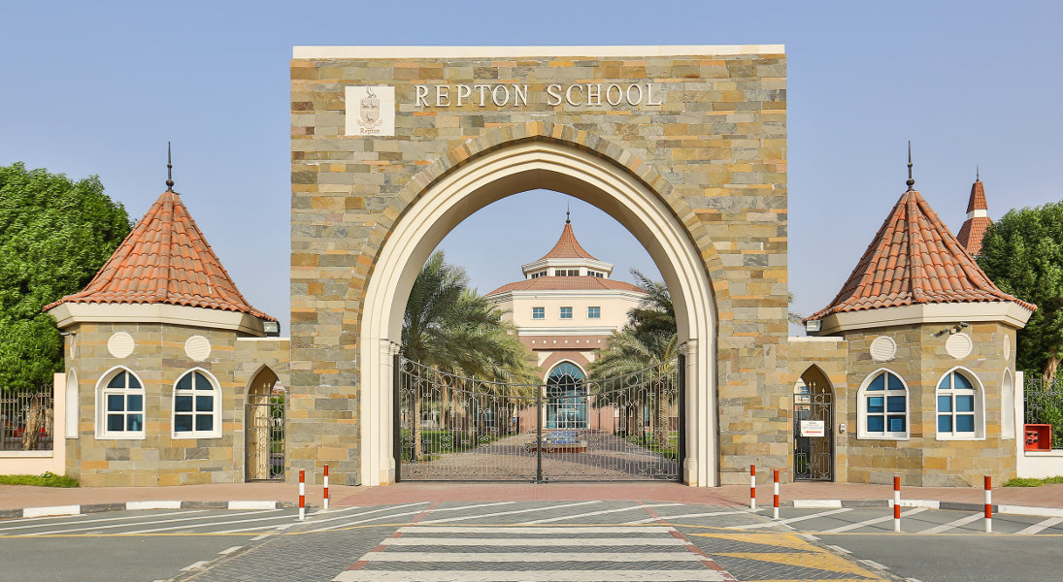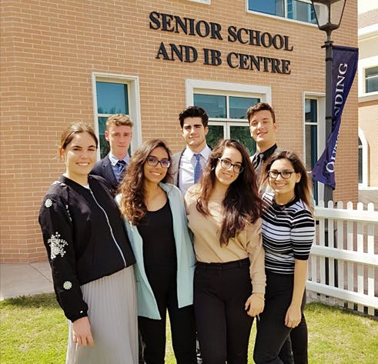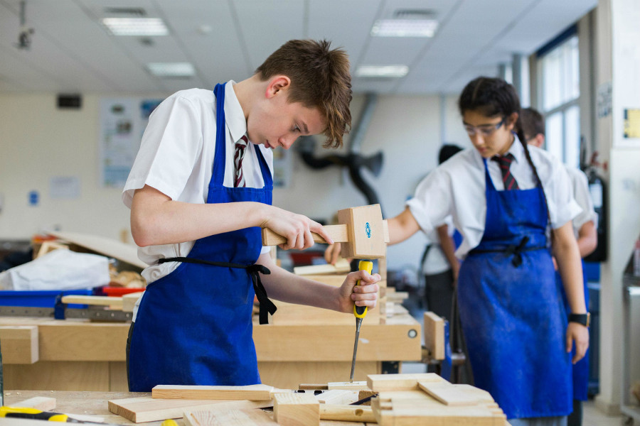

Year of establishment: 2008

Teaching language: English

Religion: None

Nature: Profit making

Number of students: 1789

International student ratio: over 50%

Largest student group: UK

Dress code: School uniform

Geographical location: suburban areas of large cities

Teacher student ratio: 1:10

International GCSE exam pass rate: 91%

The proportion of international GCSE obtaining A * - A: 51%

IB exam pass rate: 98%

IB average score: 34/45

The proportion of IB equal to or higher than 35: 41.7%

UAE government rating: Outstanding

**School Introduction**

Repton School Dubai is a well-known international school located in the center of Dubai. As one of the few truly international schools in the Gulf region, Lipton combines the good reputation and academic rigor of the UK curriculum (including IGCSE courses for grades 10-11), and provides IBDP and IBCP for students in the last two years of high school, presenting both challenges and opportunities. The Lepton campus has excellent conditions, allowing students to fully enjoy advanced facilities, high-quality resources, lively classrooms, and rich sports activities, which is enviable by peers in other schools. Our founding school, Repton Schooll, is located in England and was founded in 1557.

**Introduction to Education System**

The school provides daytime education for students aged 3-18 and boarding education for students aged 11-18. The school not only offers students an IB (International Baccalaureate) with 45 optional courses, but also offers a full range of IGCSE (General Certificate of International Secondary Education) courses. Six months after the opening of the senior children's school section, the school was awarded the IB (International Baccalaureate) international school qualification. Among 2590 IB international schools in 134 countries around the world, Repton is one of the three schools that obtained this qualification in a short period of time.

The academic system of Dubai Repton School is divided into three semesters, with September December being autumn, January April being spring, and April June being summer. The school adopts the British education system, with British education for grades 11 and below. The IB system is adopted for grades 12 and 13.

The subject settings are divided into three categories. The curriculum for students in grades 7-9 (6-8) is equipped with mandatory courses (mathematics, English, science) and elective courses. 9th grade (8th grade) students will choose the two-year IGCSE (General Certificate of International Secondary Education) course after completing all guided courses. After obtaining the IGCSE (General Certificate of International Secondary Education), students in 11th grade (10th grade) who score B or above in at least six courses will advance to the sixth level to complete all IB (International Diploma) courses.

Early Education (Kindergarten&Preschool)

EYFS Early Preparatory Course Project

Reading and Writing (Acoustic Teaching)

Focus on motor skills

Social, emotional, and physical development

Lay the foundation for core subjects

French and Arabic courses

Music, Sports, and Swimming Professional Courses

·Lower grades (grades 1-4)

Emphasize acquiring life skills such as confidence, creativity, and curiosity

Core courses include English, mathematics, science, art, music, physical education, and ICT

Mental arithmetic course

Competitive sports courses

Outdoor education courses

Extracurricular music teaching courses in collaboration with Music Box

·Middle grade (grades 5-8)

Core courses include English, mathematics, science, art, music, DT, physical education, and ICT

All courses are equipped with high-quality full-time teachers

Language courses include Arabic, French, German, and Spanish

Muslim education (for Muslim children), social learning and moral education

International study courses and local visit/activity courses

Extracurricular music teaching courses in collaboration with Music Box

·Senior year (9th to 11th grade): Preparation and completion of the IGCSE exam

Core courses include English, British literature, mathematics, biology, chemistry, physics, language courses (Arabic/French/German/Spanish), etc

Optional courses include art, drama, music, business research, computer science, DT, economics, geography, history, sports, and psychology, as well as extracurricular music teaching courses in collaboration with Music Box

·IB course project (IB1-IB2) (grades 12-13)

Two years of rigorous academic courses allow students to prepare adequately before entering university.

The IB Diploma (IBDP) is a balanced and rigorous qualification certificate with 50 years of high-quality educational achievements. Students are required to take English and mathematics, as well as at least one science, at least one humanities, one language subject, and one subject selected from art or other disciplines.

The IB Career Related Program (IBCP) combines career and academic research with a core curriculum; Studying a BTEC course (Business or Sports) for IBCP students will help them with the two IBDP topics they have chosen and complete the core issues, with the assistance of experienced career and university guidance teachers.

**Boarding system**

Dubai Repton School is one of the few schools in the Middle East that provides boarding services. Dubai Repton School has two student apartments located in the center of the campus, one for boys and one for girls. Students have multiple options, including staying all year round or staying temporarily for a few days when their parents are not in the city. Each apartment is equipped with experienced dormitory management personnel and accommodation teachers, as well as support from dormitory supervisors, interval year boarding assistants, cleaning staff, nurses, and qualified on-site doctors.

The student apartments in the school are built according to international high-end standards. Each apartment is occupied by two students and the space is spacious and bright. Each room has its own bathroom, 24-hour hot water, air conditioning, and high-speed Internet access. In addition, the student apartment also has a student activity center, fitness center, and other related facilities.

After students reach the sixth level, they will move into a single room, with each apartment equipped with a public rest area, a library, a living room, and a public kitchen.

**Application process and materials**

1、 Application process

1. Contact the Admissions Office

Phone: 800 REPTON (737866)

Email: admissions@reptondubai.org

2. Make an appointment to visit the school

Schedule campus visits through phone or email

3. Online application

Parents can access the school's official website together（ https://www.reptondubai.org/application/ ）Fill out the form online for application

4. Evaluation

The school will conduct an overall evaluation of the student situation and reply to the final result via email within three days

2、 Application materials

1. Student passport front page and visa copy (visa can be submitted after enrollment)

2. Registration photos of students and parents

3. Fill out the school application form (can be filled out online)

4. Copy of parent's passport homepage, visa, and UAE ID card (visa and ID can be submitted after enrollment)

5. Student birth certificate (English translation required)

6. Student Vaccine Card (English translation required)

7. Student transcripts for the past two years (English translation required)

8. Student transfer certificate (English and notarized certification required)

9. Recommendation letter from original school teachers (English translation required)

Lycee Francais International Georges Pompidou School Oud Metha

LFIGP is one of the five French speaking schools in the United Arab Emirates

Address: Street # 19 Oud Metha Rd - Oud Metha - Dubai

Tuition fee: 29670AED

LFIGP welcomes nearly 2900 students from over 50 countries, located in four locations: Oud Metha, Academic City Primary School, Academic City Middle School, and Sharjah

LFIGP is approved by the French Ministry of Education and is applicable to courses from Petite Section to Terminale

LFIGP is a goal, curriculum, and methodology set by the French Ministry of Education, providing education at all levels in accordance with the instructions of local education authorities

The success rate of Brevet's national diploma and bachelor's degree fluctuates between 97% and 100% annually, with the majority mentioned

For over 40 years, LFIGP has set itself the goal of pursuing excellence in a diverse environment that is conducive to everyone's development and success

# Dubai British School

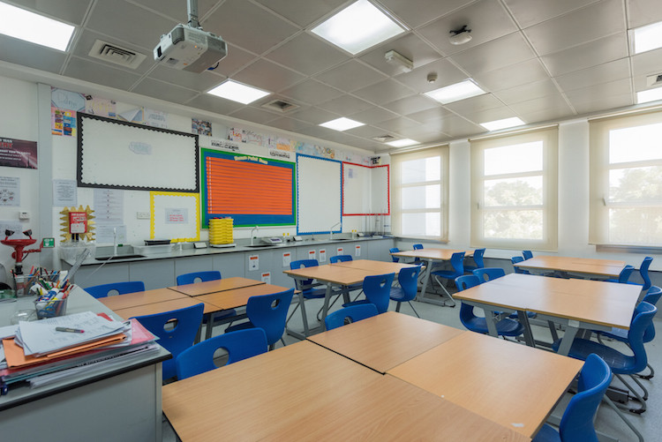

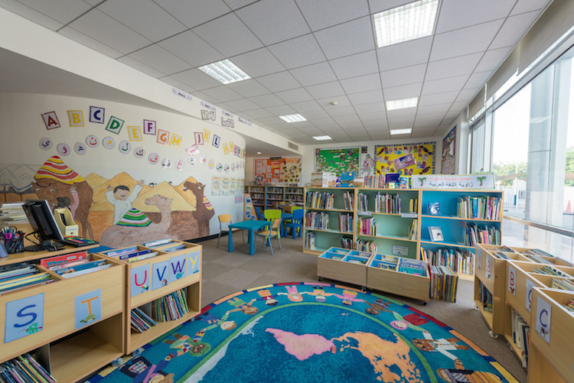

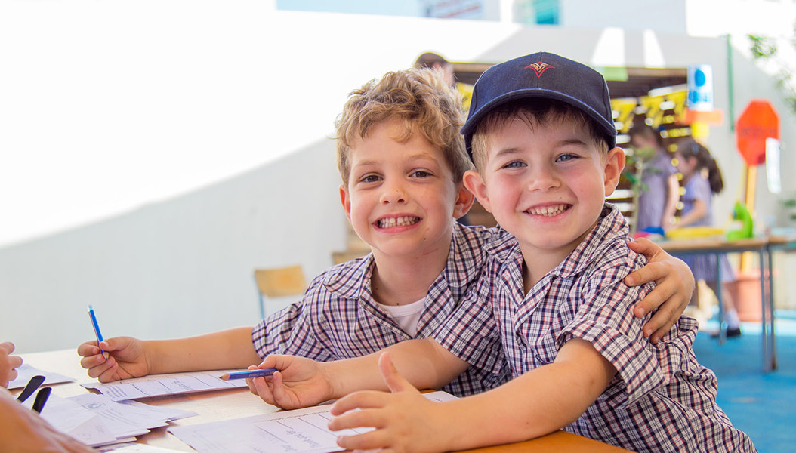

School system: English system

Current rating: Outstanding

Enrollment grade: FS1-13 grade

Tuition fee: AED -50496-75746

Address: Springs 3, Emirates Hills, Dubai

**School Introduction**

Dubai British School (DBS) was founded in 2005 and provides comprehensive and balanced education for children from all over the world. It is now one of the top British School in the region. As a member of the Taaleem Group School, DBS provides high-quality education to over 1000 students aged 3 to 18. Dubai British School is an accredited member of the International School Council, meeting a series of strict standards set by a major institution in the international education sector, and regularly undergoing inspections by the Dubai School Inspectorate (DSIB).

**Course settings**

The course is based on the UK national curriculum and reinforced through WOW learning, with Arabic language learning throughout. There is also a series of challenging GCSE and A-Level courses for grades 10 to 13. DBS's curriculum aims to expand and inspire all of these courses, regardless of children's interests or abilities.

Basic stage

The basic stage connects family and school, initiating a learning partnership that brings children's early childhood education into primary school and future learning, actively encouraging children to explore their learning environment, and creating a positive and optimistic social atmosphere. Utilize a range of resources for both internal and external learning, encouraging positive oral and listening skills. Early independence, problem-solving ability, and self-confidence lay the foundation for future learning. Personal, social and emotional development, literacy, communication and language, mathematics, understanding of the world, physical development, expressive art and design are all interrelated. Each field of the "Early Foundation Stage" course is depicted in the daily lives of children.

Primary school curriculum

The DBS primary school curriculum is based on skill based learning methods at the basic stage of the school, with imaginative, diverse, and creative courses carefully planned to meet the needs of children. The outstanding curriculum is based on the UK national curriculum and adapted to Dubai's unique environment. DBS also has an innovative and creative course that reflects best practices in the UK, which identifies differentiated courses tailored to children's individual learning goals throughout the course; Evaluation is both formative and summative, enabling teachers to fully tap into the potential of children based on their overall qualities and depict a picture of a "whole child". Throughout all stages of primary education, DBS, influenced by its creative and expressive curriculum, utilizes academic precision and rigor to give children the opportunity to unleash their maximum potential.

Middle school stage

Dubai British School still adhere to the UK national curriculum throughout key stages 3, 4, and 5 of secondary education. At KS4, students will take the GCSE exam, while at KS5, they will take the A-Level exam (an internationally recognized qualification exam for higher level learning). This course is taught in an environment of independent learning and advanced thinking skills development, while also reflecting individuality, adventure, and independence. Students can enjoy first-class facilities and resources under the guidance of high-quality and experienced teachers. In addition to teaching courses, the school also strongly encourages students to participate in various activities offered by the school, such as ECA programs or family activities, school trips, the Duke of Edinburgh Rewards Program, and various other activities offered by the school. One of the key successes of DBS in the past 10 years has been the establishment of close relationships between parents and schools. In addition to regular reports and parent meeting cycles, each student in high school is assigned to a mentor group, with an organizing mentor who meets with them every day and can discuss issues and meet with parents at any time.

Critical Stage 3

In grades 7 to 9, the school still focuses on a plan that strictly follows the UK national curriculum, which provides students with the opportunity to learn a wide and balanced range of subjects. The regular evaluations conducted during the KS3 program provide parents and teachers with the opportunity to compare the learning situation of Dubai children with students of similar ages in the UK. The curriculum allows students to learn various subjects in various fields, from core subjects in English, mathematics, and science to history, geography, languages (Arabic, French, German, Spanish), ICT, DT, music, drama, sports, Arab social studies, and Islamic studies. There is also a plan aimed at the comprehensive development of individual, social, and health education for students. The entire critical stage 3 is prepared to allow students to choose the subjects they want to study in the GCSE course, which will completely determine their development direction. Regularly evaluate students throughout critical stage 3 and follow up on their progress based on their goals in each subject to ensure they always fully unleash their potential and learn in the subjects they choose.

Critical Stage 4

GCSE is an internationally recognized qualification certificate managed by the Examination Committees in England and Wales. The evaluation varies by subject, but a combination of external examination and control evaluation. All students in the fourth critical stage will study GCSE exam courses: English literature, mathematics, science, and other science subjects, as well as five elective subjects. In addition, they also study core subjects such as physical education, personal, social, and health education (PSHE), as well as Arabic language for Arab students and Islamic studies for Muslim students. Obtaining a GCSE or IGCSE certificate for a two-year program is awarded at the end of the 11th grade of the course.

Sixth Form

The goal of the Sixth Form is to cultivate further curiosity, critical thinking, creativity, adaptability, communication skills, and independent work habits.

Sixth Form students are the main members of the school community, providing role models for younger students.

The performance level of DBS students has always been higher than the benchmark level in the UK, obtaining degrees from world-class universities such as Cambridge University in the UK and Johns Hopkins University in the US (please refer to ⑤ University Admissions for details).

Post 16

The Post 16 course includes core elements and a wide range of A Level exam subjects, from which students can choose learning areas that are suitable for their abilities, interests, and higher education options, as well as some career choices. The core of individual, social, and health education, as well as a wide range of extracurricular activities, ensure the breadth of student education.

**Extracurricular activities**

The opportunities enjoyed by students outside of the classroom are equally important as the main course. DBS offers a wide range of extracurricular activities, such as ECA programs or family activities, school trips, the Duke of Edinburgh Awards program, and various other activities offered by schools. We strongly encourage students to not only improve their learning skills, but also cultivate other interests and hobbies. The activities provided by the school for children involve various aspects such as sports, expansion, service, and culture, allowing each child to participate and hone their other skills while expanding their knowledge.

DBS Internal ECA:

ECA is considered an important component of the DBS learning environment, and schools actively encourage all students to fully utilize the opportunities provided. The main equipment and facilities used in the ECA project are mainly on campus, and when there are individual projects that require them, off campus equipment will be used. ESM will interact with all external agencies, and any questions related to activities can be raised to them first.

**tuition**

Application fee: 525 dirhams

PK tuition fee: 49026 dirhams

K tuition fee: 49026 dirhams

1st grade tuition fee: 49026 dirhams

Tuition fee for 2nd grade: 49026 dirhams

3rd grade tuition fee: 56034 dirhams

4th grade tuition fee: 56034 dirhams

5th grade tuition fee: 56034 dirhams

6th grade tuition fee: 56034 dirhams

7th grade tuition fee: 66545 dirhams

8th grade tuition fee: 66545 dirhams

9th grade tuition fee: 66545 dirhams

10th grade tuition fee: 66545 dirhams

Tuition fee for 11th grade: 66545 dirhams

Tuition fee for 12th grade: 73540 dirhams

Tuition fee for 13th grade: 73540 dirhams

**Application Information**

Visa support: not provided

School start date: September

Other enrollment dates: enrollment at any time

Application deadline: Apply at any time

Is admission based on academic performance: No

Admission waiting list: Usually there are

ESL tutoring: providing personalized tutoring

Application materials and requirements:

- Recommendation letter

- Entrance Examination

- Passport scanned copy

Email: reception@dubaibritishschool.ae

Phone:+97143619361

Application webpage (in English): <https://www.dubaibritishschool.ae/admission/how-to-apply.html>

# Horizons English School LLC

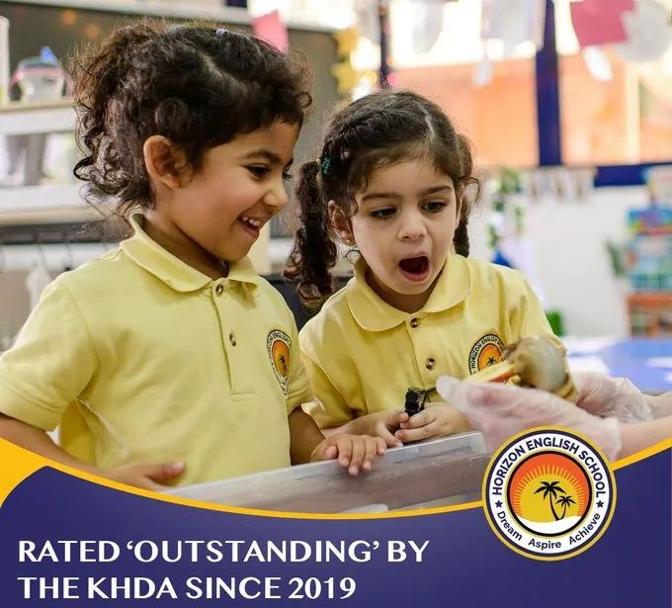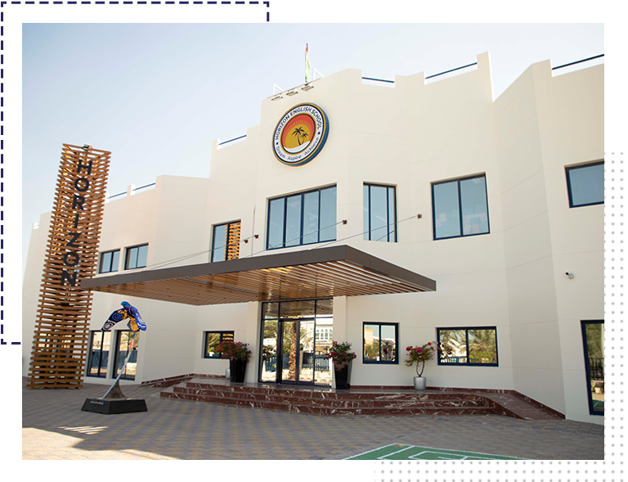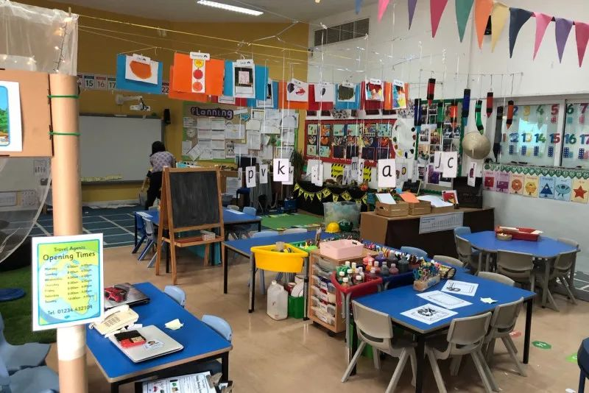

**School Introduction**

Horizon English School (HES) is a school with only the primary school section. The school has received a "very good" rating for three consecutive years and a "outstanding" rating from KHDA in 2018-19. According to feedback from parents on the WhichSchoolAdvisor.com website, Horizon English School is the primary school in Dubai that has received the highest satisfaction from parents and students.

Horizon English School was founded in 1989 and is a member of the British Middle East School (BSME). There are over 1000 students in front of this school, who come from approximately 70 different countries, but the largest student group is from the UK. The school employs 69 full-time teachers (mostly from the UK) and 38 teaching assistants. The class size of the school ranges from 19 to 26 people, and the ratio of teachers to students has always been maintained at 1:14.

**School History**

Horizon English School (HES) was founded in 1989 and is an inclusive private primary school. As one of the oldest schools in Dubai, the school provides British curriculum education for children aged 3-11. The original HES was a villa school with only 12 children, and now the school has over 1000 children. However, the school has always maintained our educational philosophy: striving to cultivate independent learners and critical thinkers, academic excellence as the core teaching plan, cultivating well-rounded children, and cultivating children who dare to make mistakes and learn from them.

Horizon English School welcomes students with special education needs. The school has a dedicated and firm identification procedure to ensure that the needs of special education and disabled students are addressed early. This academic year, approximately 50 students received special education support from the school's SEN group. This also reflects the lack of elitist education at Horizon English School. The educational purpose of providing universal education.

**School system**

In March 2021, Horizon English School announced that it had been acquired by Cognita Group and would become Cognita's second school in the United Arab Emirates. The first one is The Royal Grammar School Guildford Dubai, which was opened to students in September 2021. Both schools will offer the UK national curriculum.

Cognita, headquartered in the UK, was founded in 2004 and opened its first overseas schools in Spain and Singapore in 2007. Cognita Group provides heuristic quality education and aims to become the world's best education group. As of the end of 2020, the group has 82 schools in 11 countries and provides education in 9 different courses to 55000 students. The recent appointment of David Baldwin as the General Manager of the Middle East region at Horizon English School highlights the connection between HES and Cognita. Mr. Baldwin served as the principal of the school from 2013 to 2015.

**tuition**

The tuition fee ranges from 40872 dirhams for FS1 and 48740 dirhams for FS2 to 54770 dirhams per year for grades 1 to 6.

# Dubai English Speaking School

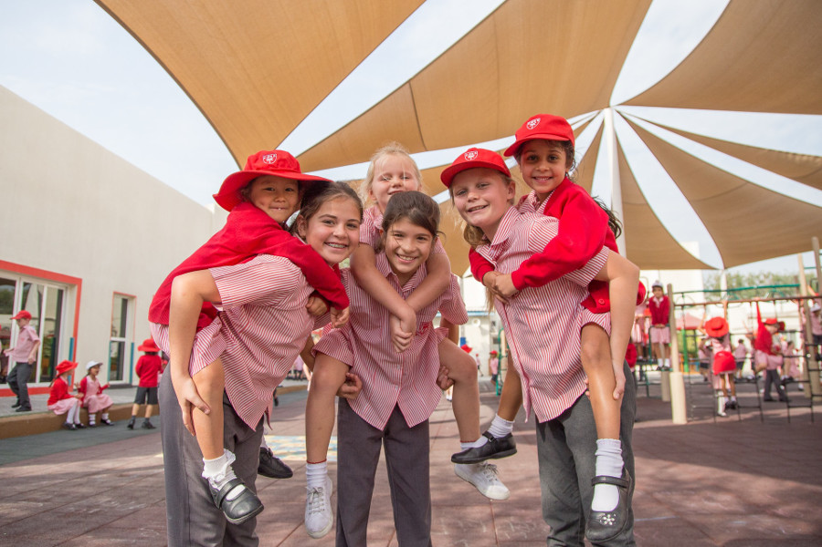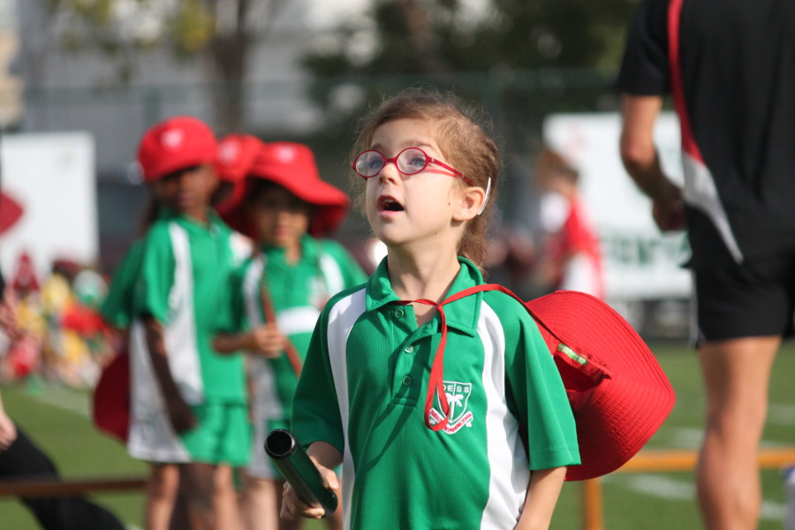

School system: English system

Current rating: Outstanding

Enrollment grade: PK-6 grade

Tuition fee: AED 36210-44813

Address: Umm Hurair

**School Introduction**

Dubai English School is the oldest British school in the United Arab Emirates, founded in 1963 by former Dubai ruler Sheikh Rashid. The school is a non-profit organization managed by a council, so there is significant reinvestment in both the long and short term, ensuring excellent facilities. Dubai English School is one of the most mature schools in the United Arab Emirates and the first school to offer British courses. The goal of the school is to cultivate independent and confident students who can actively respond to challenges and unleash their potential. DESS aims to develop students with self-worth and mutual respect. These qualities are crucial for students when facing future challenges.

**Course settings**

The DESS course develops and teaches 4Cs in all subject areas, encouraging children to master their own skill development, identify areas of advantage, and their subsequent steps. The children participated in designing the logo from the beginning and chose the font and color for each 4C!

The 4Cs: Collaboration, Communication, Critical Thinking and Creativity.

FS1+FS2

The specific areas of study in this learning stage include:

Learn to read and write in terms of reading and writing abilities; Learning numbers, shapes, and measurements in terms of mathematical abilities; Learn about characters, the world, and technology in terms of understanding the world; And improve the ability to use media and cultivate imagination in art and design.

Year 1-Year 6

In primary school, children need to learn Islamic education, Arabic, English, French, mathematics, geography, history, art, science, physical education, and other courses. The classroom is large and spacious. The Arabic department has its own classrooms, and staff can design their own patterns. They are committed to continuous professional development together with all other team members of DESS. Sixth grade students have a more specific curriculum system (leader led learning) aimed at developing their independence based on 4C feedback.

**Course Overview**

1 Arabic

FS: Arabic is not taught at this stage

KS1: Children officially begin learning Arabic as part of their first year of curriculum, with a focus on learning the Arabic language through active learning and singing. In the second grade, children continue to learn through the use of various resources and begin more curriculum based courses through positive strategies adopted by teachers. The children entered the ability group starting from second grade. By the end of the second year, most children can read and write simple phrases in Arabic.

KS2: In KS2, children continue to learn vocabulary and grammatical structures in various contexts as part of the thematic curriculum. All language skills are integrated into children's learning, but the focus is on developing reading and writing skills to provide children with good Arabic knowledge and lay the foundation for secondary school learning.

2 French

At DESS, starting from grade 3, one hour of French is provided per week. Children can also participate in popular French clubs. In the curriculum, the school's teaching methods rely on active learning, using sports, music, and drama to support students' vocabulary learning. The children quickly constructed 4th grade difficulty morning sentences and wrote down relevant paragraphs. DESS focuses on conversations about writing skills, believing that if children can say a sentence, they can also write it down.

3 Geography

The geography curriculum of Dubai English School is based on the framework of the UK national curriculum, catering to the various needs of the international school community.

4 History

High quality history education will help students gain an understanding of the UK's past and the wider world, including the UAE. The history course is based on the framework of the UK national curriculum and caters to the various needs of the international school community.

5 Islamic education

According to the requirements of the Ministry of Education, Islamic education is provided weekly by high-quality and experienced teachers to all children in grades 1 to 6.

6 Mathematics

Mathematics courses enable children to establish mathematical understanding and provide them with opportunities to enjoy learning and persevere in challenges.

7 Arts

The school provides after-school activities, including KS1 and KS2 choirs, samba, brass bands, and guitar clubs. Then encourage children to participate in all annual activities, including the DESS festival, the UAE Arts Festival opening ceremony, and the annual choir competition.

8 Sports

The DESS PE department has 8 employees. As a department, set goals, develop lifelong habits for children, and maintain physical health. The focus of this department is to enhance the physical activity potential of each child. All fields of PE include swimming, gaming, athletics, gymnastics, and dance.

9PSHE

PSHE is about personal, social, and health education for children. DESS's PSHE course aims to provide students with the necessary knowledge, understanding, attitudes, values, and skills to unleash their personal potential.

10 Science

In science courses, students cultivate skills in planning, hypothesis, prediction, observation, measurement, classification, interpretation of data, inference, and communication. In the course, ensure contextual relevance, make student activities relevant to their learning, and better understand the world around them.

11 Reading and Writing

Reading and writing are essential skills, and children can make outstanding progress in both course areas.

DESS's curriculum covers the 2014 UK national curriculum system, ensuring strict spelling and grammar teaching methods.

**Extracurricular activities**

All areas of PE include swimming, gaming, athletics, gymnastics, and dance. The school provides a variety of pre class and post class activities. The school will also hold annual sports and competitions to allow children to apply the skills and knowledge they have learned in competition. At Dubai English Speaking School, competitive sports are very popular. In recent years, there has been significant improvement in the performance of all major games and tournaments. These can now be listed as outstanding sports.

**tuition**

Application fee: 525 dirhams

PK tuition fee: 37334 dirhams

K tuition fee: 46204 dirhams

1st grade tuition fee: 46204 dirhams

Tuition fee for 2nd grade: 46204 dirhams

3rd grade tuition fee: 46204 dirhams

4th grade tuition fee: 46204 dirhams

5th grade tuition fee: 46204 dirhams

Tuition fee for 6th grade: 46204 dirhams

# Kings School Al Barsha

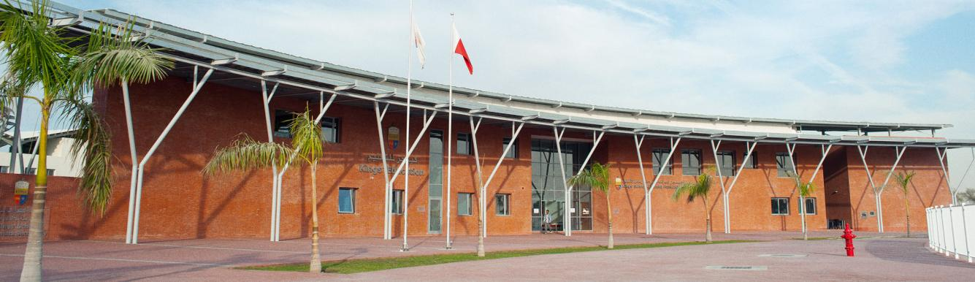

King's School Albasha is an excellent British primary and secondary school that caters to both global and local families. The school was established in September 2014 and is a part of the King's Education Group, which was founded in 2004. Dubai King's School is the only school in the United Arab Emirates to receive the KHDA "Excellent" rating for 10 consecutive years.

The school adheres to the value of "every child is the best" and views it as a community that includes leaders, teachers, support personnel, parents, and children, supporting students to fully realize their potential.

Year of establishment: 2014

Course type: International A levels, International GCSE

Cost: 53622-97798AED

Grade: FS1-13 Grade

**School Introduction**

The King's School Albasha aims to provide top-notch British primary and secondary education for local and even global families. Our school adopts the UK national curriculum and has made corresponding adjustments to provide a conceptual and comprehensive learning experience for the international community composed of multiple countries around the world. Therefore, our school has customized rigorous courses for students. These courses focus on the characteristics of children growing up in Dubai, but their purpose is to cultivate happy and successful global citizens, helping them to establish a place in the future world. In addition, our school has top-notch facilities, including advanced technology that can be seen everywhere on campus, specially designed science laboratories, design, technology and art suites, spacious performing arts venues, and stunning sports facilities.

**Basic information**

Year of establishment: 2014

Teaching language: English

Religion: None

Nature: Profit making

Number of students: 1660

International student ratio: over 50%

Number of student countries of origin: 60

Largest student group: UK

Dress code: School uniform

Geographical location: suburban areas of large cities

**Teaching quality**

Teacher student ratio: 1:10

The proportion of international A Level obtaining A * or A: 62%

UAE government rating: Very Good

**Academic courses**

Course type: International A levels, International GCSE

Social science subjects: History, Business Studies, Geography, Religious Studies, Psychology, Sociology, Economics, Communication and Information Technology

Literature and Language Subjects: French, English (Literature), Spanish, Arabic

Mathematics subjects: Mathematics, Supplementary Mathematics, Computer Science

Science subjects: chemistry, physics, biology, art projects, instruments, bands, choirs, fabric handicrafts, theatrical production, theatrical performance, photography, printmaking reproduction, orchestral music, painting, design and craftsmanship, pottery, sculpture

Sports: Cricket, swimming, athletics, basketball, dance, ballet, British baseball, rugby, blue tennis, touch rugby, cross-country, football

**Student organizations and clubs**

LEGO, Fitness, Club, Cooking, Business, Origami, Handicraft, Photography, Duke of Edinburgh Award

**School culture**

All branches of King's School adhere to the same core values: "The Best By Every Child.". This is the top priority of our work and the direction we strive towards every day. As a collective (including leaders, teachers, logistics personnel, parents, and children), we deeply understand that building strong partnerships and working together is the best way to help our children fully realize their potential. We believe that schools should be a very special place, filled with joy, curiosity, and a thirst for knowledge, with inspiring teachers, challenging learning experiences, and rich and unforgettable activities.

Our school is a member of King's School. King's School is a well-known school alliance that follows British tradition and has a strong international perspective. The children here are enthusiastic and independent lifelong learners with the ability to adapt to the rapidly changing modern world and face challenges. Our uniqueness stems not only from our excellent grades, strong faculty, and first-class facilities, but also from the guiding principle of "The Best By Every Child" that we strive for every day.

**tuition**

Application fee: 1000 dirhams

PK tuition fee: 53622 dirhams

K tuition fee: 53622 dirhams

1st grade tuition fee: 56079 dirhams

Tuition fee for 2nd grade: 56079 dirhams

3rd grade tuition fee: 61099 dirhams

4th grade tuition fee: 63022 dirhams

5th grade tuition fee: 68042 dirhams

6th grade tuition fee: 68042 dirhams

7th grade tuition fee: 79461 dirhams

8th grade tuition fee: 82569 dirhams

9th grade tuition fee: 85574 dirhams

10th grade tuition fee: 91686 dirhams

Tuition fee for 11th grade: 97798 dirhams

Tuition fee for 12th grade: 97798 dirhams

Tuition fee for 13th grade: 97798 dirhams

Scholarship: Provided

**Application Information**

Visa support: not provided

School start date: September

Other enrollment dates: enrollment at any time

Application deadline: Apply at any time

Grade for accepting new students: PK-13

Admission waiting list: Usually there are

Application materials and requirements:

- Transcripts from the past two years

- Entrance Examination

- Online assessment

- Passport scanned copy

Email: admissionscoordinator@kingsalbarsha.com

Phone:+97143566800

Application webpage (in English): <http://kings-edu.com/albarsha/how-to-apply/>

# Dubai Interational Academy

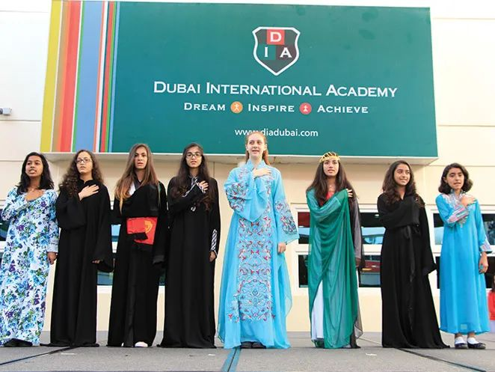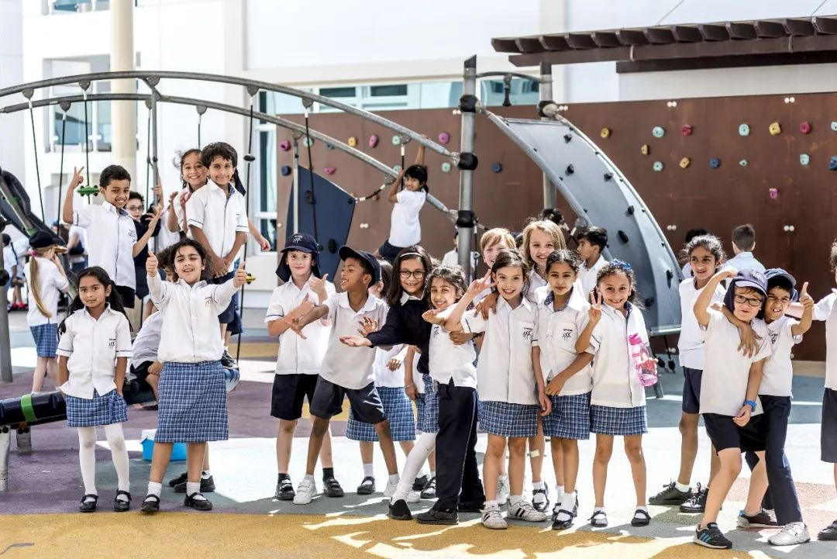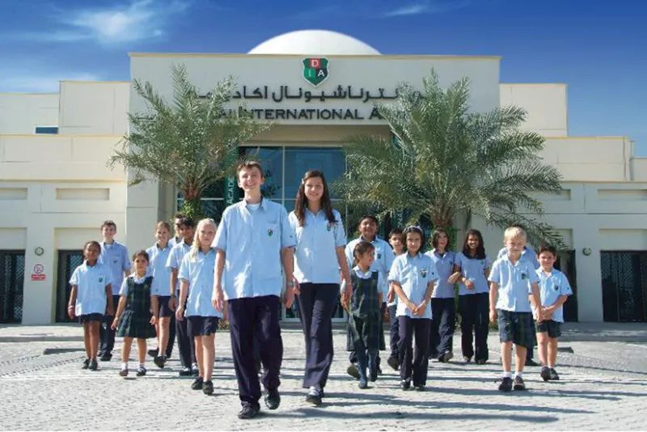

Dubai International Academy is the first IB program school authorized by the International Baccalaureate Organization of the United Arab Emirates to offer full stage IB courses. In 2015-16. As the first IB school in the United Arab Emirates to receive an outstanding rating (from Dubai's education regulatory agency KHDA), it maintained this rating from 2016 to 2017.

**School Introduction**

DIA was founded on September 10, 2005 at Emirates Hills, with over 500 students from 55 countries and over 50 faculty members from 18 different nationalities. Today, the school is becoming larger and has 2290 students from over 80 countries, with a faculty of 184 teachers and 34 teaching assistants. The teacher-student ratio is 1:11 (a relatively low ratio ensures that teachers can meet the needs of individual students).

**School system**

DIA is the first school in the UAE to offer the Geneva International Baccalaureate (IB) program, covering primary school curriculum (PYP, KG grades 1-6), secondary school curriculum (MYP, grades 7-11), and diploma curriculum (DP, grades 12-13).

The IBDP score of the school ranks among the top in the region, and the result is impressive. In 2021, the average total score of 133 students was 39, with a pass rate of 100% 98.5% of students scored above 30 points, 82% scored 35+points, and 48.1% scored 40 points or above. Five students received the highest score of 45.

01 Early childhood education (3-5 years old)

Mainly helping children learn and grow from six areas.

1. Personal, social, and emotional development

2. Communication skills and language reading and writing abilities

3. Digital development

4. Cognition of knowledge and society

5. Limb development

6. Art and Design and Creativity

02 Primary education (ages 5-11)

Primary education aims to help PYP learners achieve success in various fields by addressing academic, personal, social, cultural, and sports development issues. At the same time, in addition to the prescribed teaching plan, necessary after-school activities such as choirs, rugby, Arabic, etc. are added to enrich students' leisure life.

03 Secondary education (ages 11-17)

Phase 1 MYP (Y7-Y11)

Phase 2 DP (Y12-Y13)

The positive energy emanating from every student in DIA permeates the campus unconsciously, and all decisions made by the school are centered around personal development, following the internationally recognized IB system, to maximize the potential of children in two different stages of secondary school.

04IB course

The IB course is divided into six basic subject areas, where students are required to study both science and humanities subjects. All students participating in the diploma program must choose one course from each of these six subject groups for learning. Each course is further divided into advanced courses and regular courses.

The IB course is a relatively more challenging and highly recognized course, preparing students to enter university and obtain an international bachelor's degree certificate. After obtaining this certificate, students are eligible to directly enter universities in the UK and most other countries, and they may also receive up to one year of credit to enter universities in the United States. The IB course is conducted in depth, and students' learning will continue to deepen.

The IB course is recognized by the global education community as an educational program with a higher academic level, accepted by a wider range of universities and high schools, and rapidly developing and growing globally, becoming the most ideal choice for international students to enter foreign universities.

**School Information and Reports**

According to data from the Dubai Education Authority, the teaching quality of Dubai International Academy has been increasing year by year, and since 2015, it has joined the ranks of Outstanding campuses (the highest rated by the Dubai Education Authority).

Composition of teachers and students:

The faculty members of the school come from more than 30 different countries, all of whom have the qualifications of international excellent teachers. Their professional teaching level and encouragement of critical thinking are highly respected and loved by students. At the same time, the teachers in the school are constantly exploring and improving to improve themselves, and are determined to strive for the education cause for a lifetime. The current ratio of students to teachers in schools is 12:1

**School facilities**

Library; Music dedicated rooms for music technology, art, dance, drama, and language learning; Fully equipped scientific laboratories, computer laboratories, and robotics laboratories; Four temperature controlled multifunctional halls, capable of hosting various sports; Two swimming pools; A lawn style outdoor sports field and amusement area; Outdoor basketball and tennis courts; Kindergarten students are provided with dedicated music and sports rooms.

The school covers an area of approximately 8 acres and is easily accessible from Al Khail road.

**Principal's message**

Poonam Bhojani

Our organization was established in 2004 with the aim of providing "world-class" education. Since its establishment, our vision has been centered around parents, ensuring that we place the interests of our students at the core of all decision-making. The results of hard work can be seen from excellent grades in the final exams of graduation classes and university offers from world-class institutions.

We have always been committed to providing our students with comprehensive, rigorous, and international education to achieve success in a constantly changing world. After all, their success is our success. Our school and daycare have over 7750 students from over 100 countries, and we are a culturally rich international community. Most importantly, we have happy students who like to come to school every morning with a smile on their face and stumble. This is the most gratifying aspect for me to be with our outstanding young people.

**tuition**

The starting price for KG is 46658 dirhams per year, and the cost for 13th grade is 71625 dirhams.

Additional fees: Entrance examination fee of 500 dirhams, annual registration renewal fee of 3000 dirhams, new student registration fee of 7000 dirhams, and extra tutoring fee of 4500 dirhams for students using English as a second language (ESL).

# Deira International School

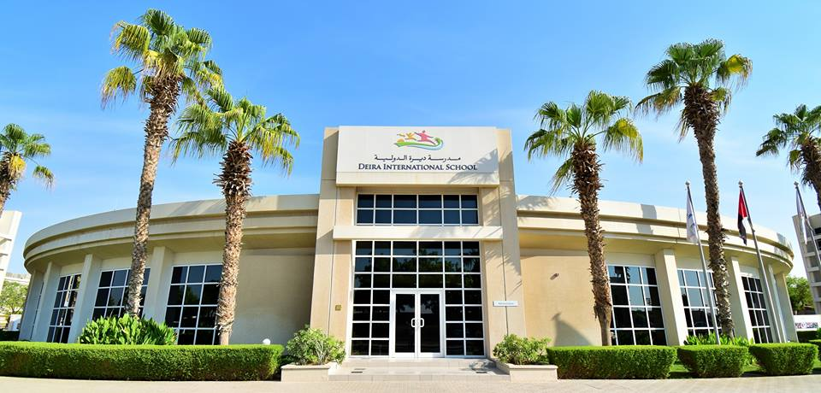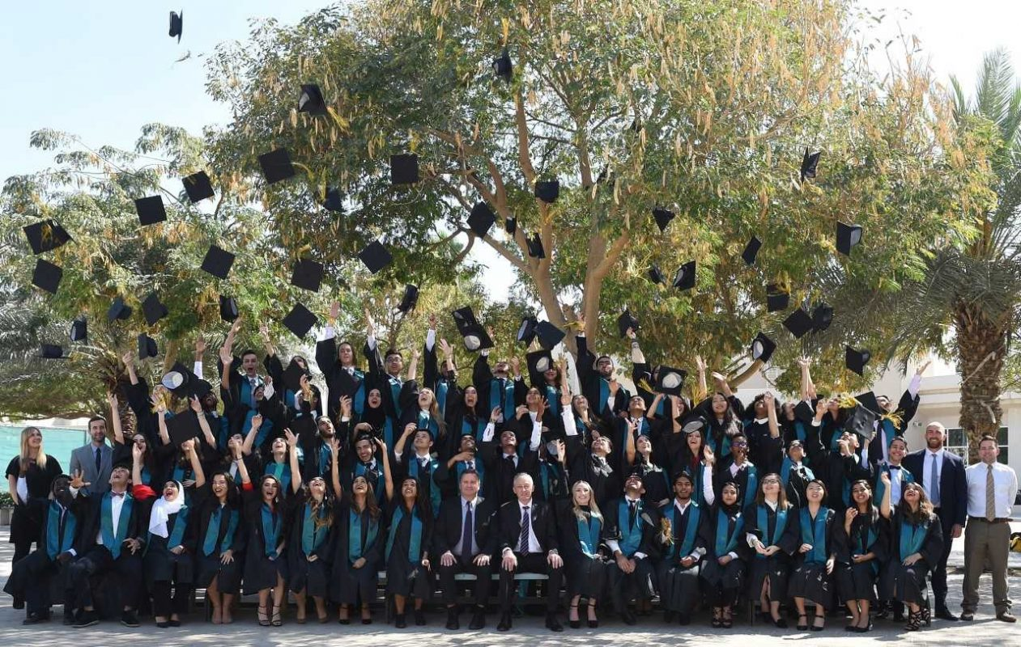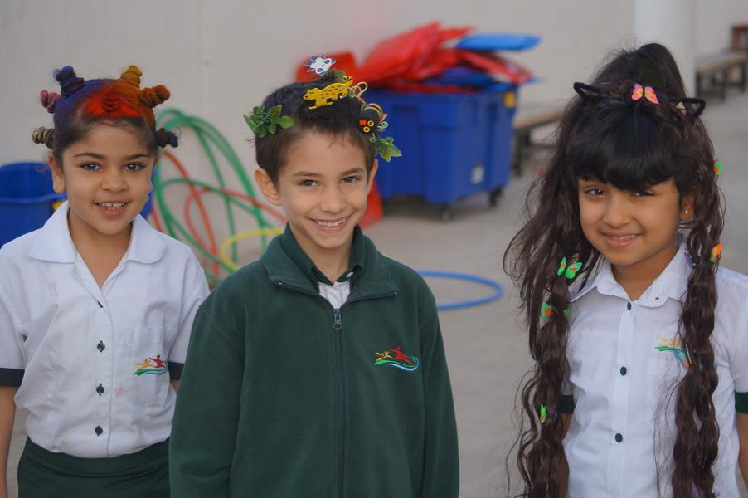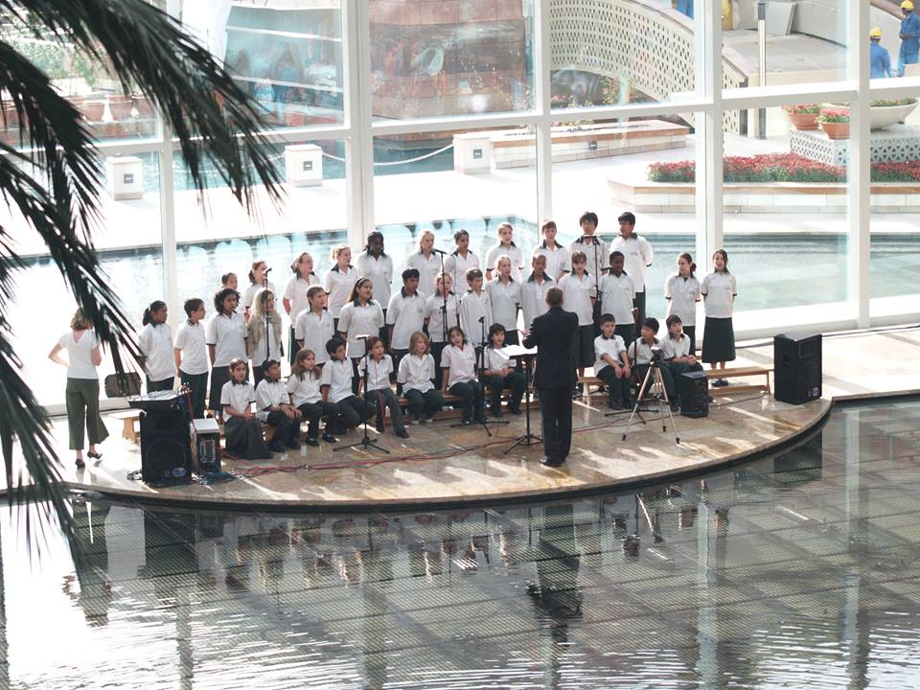

**School Introduction**

Deil International School (DIS) is a vibrant and excellent British curriculum school in Dubai's holiday city. Here, learning and working are full of fun and excitement. Our school's teachers and students respect each other and have a harmonious relationship. In such a positive and healthy learning environment, students can grow strong, full of aspirations, and achieve success. Our school follows the curriculum model of English speaking countries. Students from grades 10 to 11 will take the IGCSE exam, while students from grades 12 to 13 will take the IBDP course.

**Principal's message**

Head of School

"As a successful school we never stand still. We continue to strive for excellence through strategically developing practice and provision to continue to improve."

Ruth Burke

**Basic information**

Year of establishment: 2005

Teaching language: English

Religion: None

Number of students: 1579

International student ratio: over 50%

Number of student countries of origin: 80

The largest student group: Arab

School area: 80000 square meters

Dress code: School uniform

Geographical location: suburban areas of large cities

**Teaching quality**

Teacher student ratio: 1:10 International GCSE with A * or A ratio: 40%

The proportion of international GCSE achieving A * - C: 89% IB exam pass rate: 92%

IB Average Score: 33/45 IB Single Subject Average Score: 5.9/7

Ratio of IB equal to or above 40: 6% Ratio of IB equal to or above 35: 32%

Ratio of IB equal to or higher than 30: 77% UAE government rating: Very Good

**Academic courses**

Course types: IBCP, IBDP, International GCSE

IB Personal and Social Subjects:

Information technology, history, business studies, geography, psychology, and economics in a globalized society

IB Literature and Language Subjects: French, English, Spanish, Arabic

IB Mathematics Subject: Mathematics Learning Standard Level (SL) Mathematics Standard Level (SL) Mathematics Advanced Level (HL)

IB Science Subjects: Physical Education, Training and Health Sciences, Chemistry, Physics, Biology, Social and Environmental Systems, Computer Science, Design and Technology

IB Art Subjects: Drama, Film, Dance, Vision, Art, Music

**Sports projects**

Cricket, basketball, British baseball, rugby, blue tennis, touch rugby, football

**School culture**

Our school motto is "lifelong learning, continuous progress". We believe that all students can unleash their potential in a safe, inclusive, and forward-looking environment, and encourage each child to fully showcase their individuality. We actively establish partnerships with all parties, and students, parents, faculty, and the entire community will contribute to and facilitate the success of students and schools.

**tuition**

PK tuition fee: 39938 dirhams

K tuition fee: 39938 dirhams

First grade tuition fee: 51950 dirhams

Tuition fee for 2nd grade: 51950 dirhams

3rd grade tuition fee: 51950 dirhams

4th grade tuition fee: 51950 dirhams

5th grade tuition fee: 51950 dirhams

6th grade tuition fee: 56446 dirhams

7th grade tuition fee: 56446 dirhams

8th grade tuition fee: 60956 dirhams

9th grade tuition fee: 60956 dirhams

10th grade tuition fee: 63962 dirhams

Tuition fee for 11th grade: 72957 dirhams

Tuition fee for 12th grade: 80465 dirhams

Tuition fee for 13th grade: 80465 dirhams

**Application Information**

Visa support: not provided

School start date: September

Other enrollment dates: enrollment at any time

Application deadline: Apply at any time

Grades accepting new students: PK-10, 12

Is admission based on academic performance: No

Application materials and requirements:

- Transcripts from the past three years

- Passport scanned copy

Exam score: GCSE achieved C in 6 subjects

Email: registrar@disdubai.ae

Phone:+97142325552

Application webpage (in English): <https://www.disdubai.ae/page.cfm?p=1033>

# Victory Heights Primary School

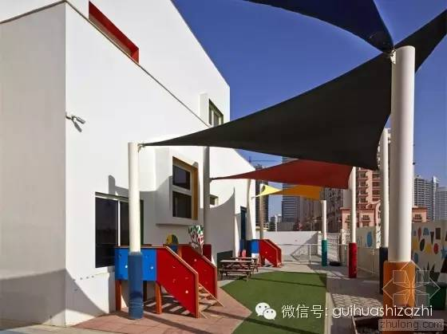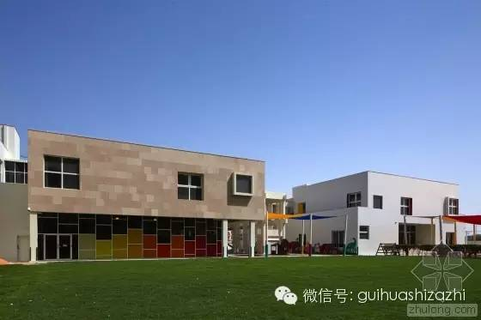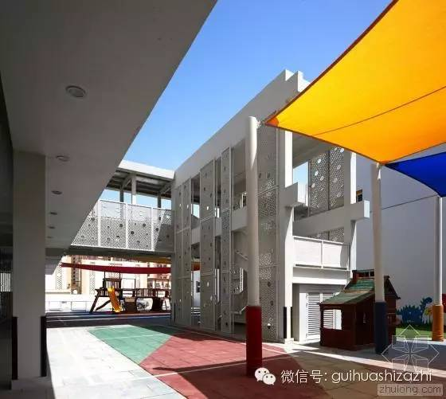

Address: Dubai Sports City

Education System: English

Grade: FS1-Y6

Tuition fee: 36576-49877AED

**School Introduction**

This British curriculum school located in Dubai Sports City has been steadily improving for many years. It opened in 2013 and was rated good in 2015-16 and 2016-17, and very good in 2017-18 and 2018-19. However, in May last year, it was finally awarded an excellent rating by overseas schools in the UK. This year, it was awarded the KHDA Outstanding rating. The cost for the basic phase in 2023/24 is 38222 dirhams, and for the sixth year it is 52121 dirhams.

**Course Introduction**

This school is a boutique British national curriculum school. VHPS provides the UK national curriculum for early foundational stages as well as critical stages one and two. VHPS focuses on core skills in English, mathematics, and science, not only focusing on teaching content, but also on teaching methods and how to measure children's development and academic progress. The course aims to establish interdisciplinary connections, ensure creative themes that make children's learning exciting, and utilize various teaching tools and methods. VHPS organizes on-site visits related to learning and focuses on developing children's skills and understanding of their knowledge.

As the core of the curriculum, VHPS also aims to develop key aspects of positive education, aiming for children to develop their power as learners, enabling them to achieve the best results in their lives. The key attributes of a project that aligns with KHDA support the ten characteristics of POSED, including creativity, curiosity, courage, integrity, resilience, empathy, fairness and tolerance, awe and purpose.

# Nord Anglia International School

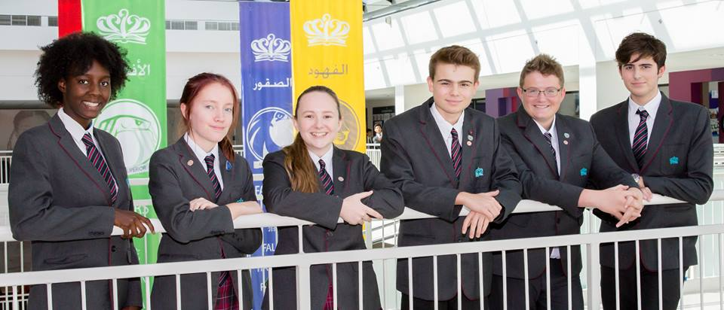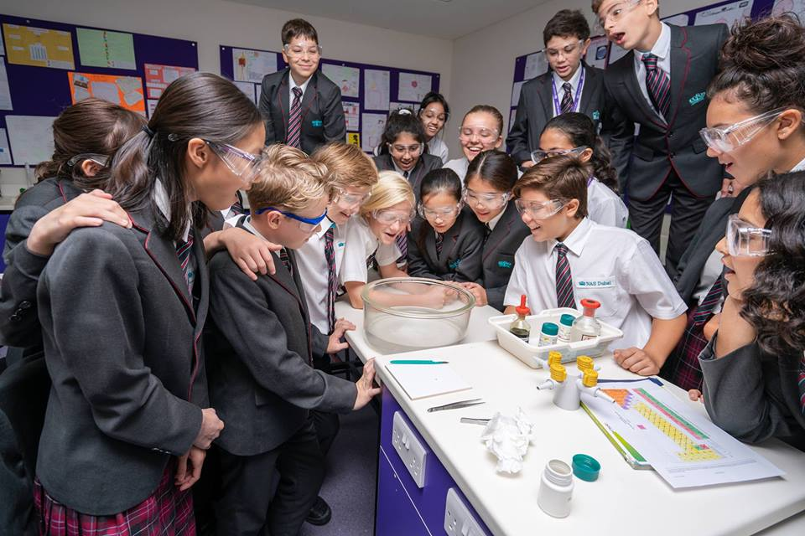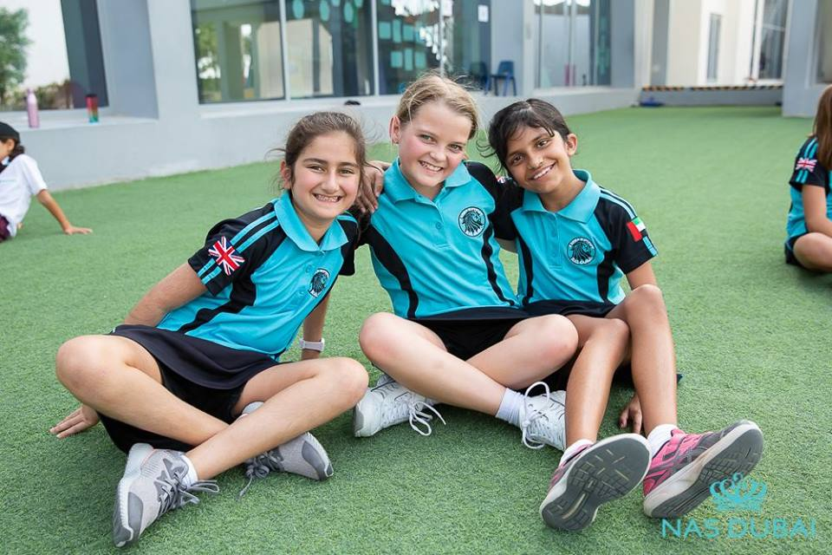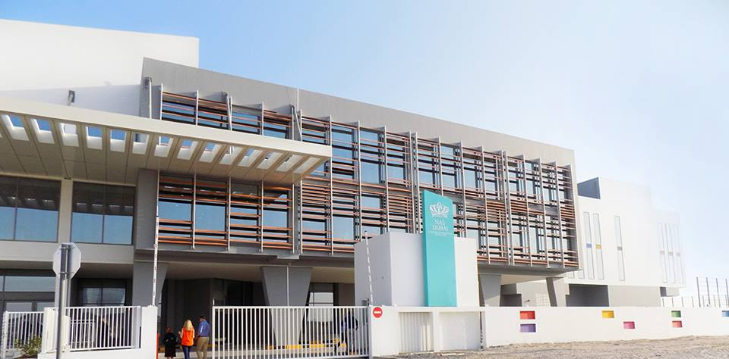

**School Introduction**

Dubai Nord Anglia International School provides personalized education with excellent teachers and facilities. NAS Dubai advocates ambitious education and believes that the achievements we can achieve for ourselves and others are infinite. We enable every student to develop the skills necessary for the 21st century, so that they can achieve success in academic, social, and personal aspects.

Dubai Nord Anglia International School provides a learning environment for success and is a leading international school in Dubai with excellent academic performance. The global learning environment of NAS Dubai motivates every student to achieve the grades required for success. By understanding how each child learns best, NAS Dubai personalizes their entire learning experience.

Year after year, IGCSE students at NAS Dubai have achieved grades higher than the average in the UK, with 98% of students achieving A+to C grades, compared to 66.3% in the UK, enabling all students to successfully enter the IB diploma program.

As a member of the Nordic Education Group's 81 school family, NAS Dubai students can also collaborate with Massachusetts Institute of Technology, Juilliard School of Music, UNICEF, and global campuses. This is an online platform that connects all Nordic students worldwide.

NAS Dubai encourages and embraces the participation of parents and students, actively listens to and responds to their needs, and establishes a social center for a unique school community.

NAS Dubai cultivates motivated and focused global citizens, created by NAS Dubai's world leading education experts. The internationally recognized curriculum of NAS Dubai reimagines education through six educational pillars, cultivating students into compassionate and responsible citizens.

**Principal's message**

The warmth of our community creates a strong sense of belonging, and the extraordinary diversity includes respect for others and an open mindset to view the world in different ways. This will support our students to thrive academically, socially, and emotionally.

Principal, Matthew Farsing

**Course Introduction**

Preschool education (3-5 years old)

The youngest students in the school follow the basic curriculum of early childhood education in the UK national curriculum, which is adjusted to meet the needs of the international community. This comprehensive, child centered curriculum prepares your children for future education by cultivating the skills, interests, and confidence they need to become creative and ambitious learners.

NAS Dubai's early curriculum provides a child centered and comprehensive learning approach. Following the Early Education Foundation Stage (EYFS) framework in the UK, our youngest students achieve their seven key areas of learning and development through games, exploration, and discovery.

EYFS course:

·Set high standards to ensure that every child can make progress

·Provide equal opportunities,

·Establish partnerships between parents and teachers.

·By learning around the unique needs and interests of children

7 EYFS categories:

·Communication and Language

·The development of physics

·Personal, social, and emotional development

·Reading and writing abilities

·Mathematics

·Understanding the World

·Expressing Art and Design

We encourage children to participate in a series of open exploration activities through child initiated learning every day. These activities aim to improve communication skills, physical development, creativity, and confidence. Children may explore pouring and sieving water in a water tray, organizing games or imaginative games, reading in quiet spaces, or creating artworks or handicrafts for the refrigerator.

A part of preschool learning is phonetics, and schools strive to ensure that children can read sounds and language from an early age. The school starts this journey with songs and rhythms, introducing oral mixing and voice recognition through daily speech activities, gradually establishing children's voice awareness.

Outdoor recreation

A lively child is happy. When visiting the outdoor exploration area of NAS Dubai, you can immediately see this. In this space, children have ample opportunities to explore the world around them as they develop their gross motor skills, problem-solving skills, and communication skills. The fun goes beyond that. Children will engage in battles using large building materials to construct, experiment, balance, and adventure.

Professional courses

Children will be delighted to participate in a range of subjects, including Arabic, music, dance, and drama, sports, and world language classes in collaboration with the Juilliard School of Music - all taught by professional teachers.

Primary school (5-11 years old)

NAS Dubai's primary school curriculum encourages children to become confident, curious, and patient learners, with a greater emphasis on developing their academic abilities. We follow the UK national curriculum, which is adapted to the learning environment of the international community and provides students with an exciting adaptive education method.

NAS Dubai follows the UK national curriculum, which focuses on core subjects such as English, mathematics, and science, while also expanding knowledge of music, art, drama, humanities, and language. We also explicitly emphasize Personal, Social, Health, and Economic (PSHE) education.

Key Stage 1 (Lower Grade):

Subjects include English, mathematics, science, Arabic, language, geography, history, arts and crafts, music, sports (including swimming), health education, and information and communication technology.

Key Stage 2 (Senior):

The subjects include English, mathematics, science, language, Arabic, humanities, information and communication technology, music, drama, dance, art, sports, social research, and DICE subjects (design, innovation, computation, and entrepreneurship).

DICE course

DICE (Design, Innovation, Computing, Entrepreneurship) subjects provide students with the opportunity to brainstorm and tackle challenging situations through collaborative and creative work. In this field of learning, students gather ideas from various fields of the course.

The visual arts course encourages students to understand the creative process and apply their learning to their own masterpieces.

After school, students can choose to participate in exciting and diverse activities. From ballet to animation, from cricket to programming - we provide each student with something to ensure they expand their imagination and maintain their thinking.

Middle school (ages 11-16)

In secondary school, students of NAS Dubai study a range of academic subjects taught by professional teachers through the UK National Curriculum, which is adapted to Dubai's international community. This prepared them for the IGCSE exam in 11th grade.

Lower grades (7-8 grades):

Learning professional subjects

Including Arabic, art, computer science, design technology, drama, English, French, geography, German, history, Islamic studies, Mandarin, mathematics, music, sports, science, Spanish, as well as DICE courses (design, innovation, computation, entrepreneurship).

Senior grades (9-11 grades):

Preparing for the IGCSE exam

Students will choose the IGCSE course in 8th grade and then begin their learning plan in 9th grade.

The courses offered by the school include a three-year core course and elective courses. All students take elective courses in English language and literature, mathematics, science, humanities, and language, and then choose courses from established sections.

Professional courses

Professional subject learning is the core of our high school curriculum. Students develop their understanding of major ideas through core subjects such as mathematics and language. Students possess curiosity and a spirit of collaboration, creativity, and critical thinking abilities to help them follow their passions and enter top universities in the world.

Performing Arts

The performing arts course for middle school students was designed in collaboration with Julia College. Students can learn about music production and gain a deeper understanding of the school's innovative dance and drama curriculum - there are many ways to showcase and develop their unique talents. Students who play (or want to learn) musical instruments, whether they are drums or cellos, have received support from the NAS Conservatory of Music.

British high school (ages 16-18)

Students at this stage can choose either the International Baccalaureate Preparatory Program (IBDP) or the Advanced Level Examination (A-Level).

International Baccalaureate Preparatory Program (IBDP)

Each student studies six subject groups: language and literature, language acquisition, individual and society, science, mathematics, and creative arts. Three are advanced levels and three are standard levels.

Students will complete core courses (knowledge theory, extended thesis, creativity, activities, and services) to obtain a complete diploma.

·Theory of Knowledge (TOK): A course that explores critical thinking, allowing students to understand how we learn.

·Extended paper: A 4000 word independent research project focused on a specific topic.

·Creativity, Activities, and Services (CAS): A series of activities that develop students' innovative skills and well-being, and support the local community of the school.

High School Advanced Level Examination (A-Level)

Students will choose 4 A-Level courses in 12th grade and 3 A-level courses when entering 13th grade. The school also encourages students to use EPQ research-based learning programs, which is equivalent to half an A-level. EPQ is to prepare for in-depth learning and research in university.

**School Experience**

(1) Encourage curiosity

From exciting adventures to world leading STEAM courses, the school will help students explore and discover new talents.

(2) Social purpose

Collaborate with the community to change people's lives, encourage students to become responsible global citizens, and prepare to leave their mark on the world.

Collaborating with the United Nations Children's Fund, plans and activities aimed at inspiring social goals, encouraging students to achieve sustainable development goals, and creating high-profile opportunities to discuss the world's largest issues with United Nations leaders.

(3) Creativity and Culture

Creative thinking is essential because it is about being able to see "possible art". By cultivating creativity and appreciation for culture, teachers will help students see opportunities in front of them and find creative ways to overcome challenges.

The content includes music, dance, drama, performing arts at the Juilliard School of Music, STEAM courses, and multiculturalism.